I got to Como in the pioggia and was tempted to grab a cab but I'm glad I didn't as I would've missed the sculpture in pic#1.

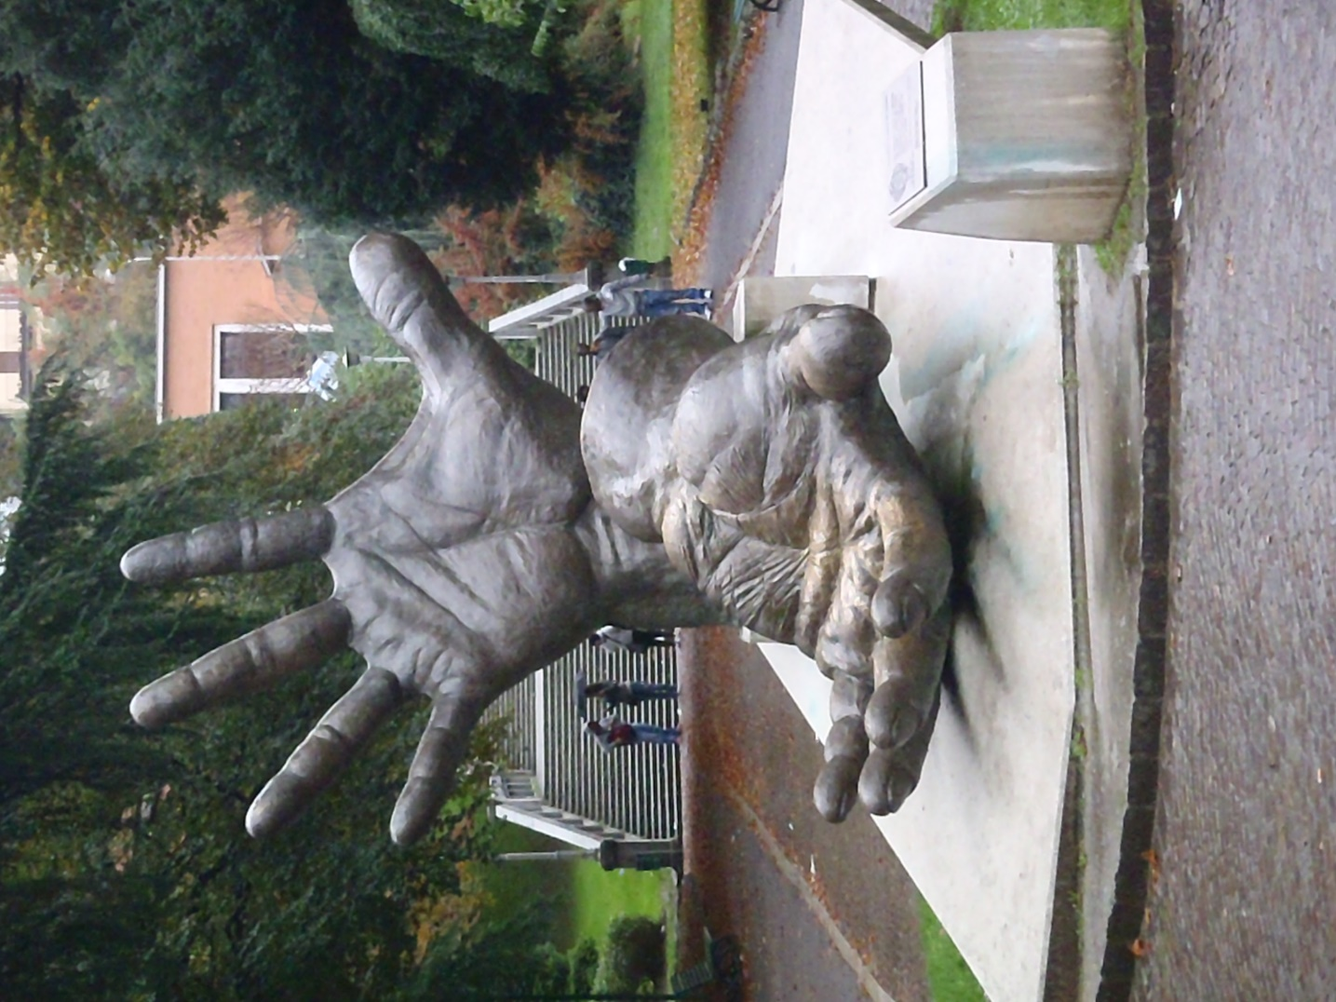

It took a few twists and turns through town before I reached the Hotel Plinius, evidently built on some Roman ruins, it still had the most modern, "boutique" feel of any place on the trip. They let me check in early so I showered off the travel grit and enjoyed a couple of beers and some snacks I'd got along way: again, prosciutto and cheese, this time in wedge-shaped tortillas…putting the "fun" in functional foods.

The rain intermittently tapped against the shutters as I spread two maps out on the desk and bed. You'd think it would be easy to find the lake but the town's streets were twisty and narrow and the buildings right up against each other, I guess, a lot like every other town except here the flow of people was a swirling mob of shoppers, locals, and vagrant wanderers (such as myself) that it was kinda hard to tell where it all led. Eventually, I made my way through the labyrinth to the lakeshore with the rain only coming down off and on…nothing my 20-year old Moonstone rain jacket couldn't handle (shameless product plug).

The magic of this spot really opened up at the shore. There was a funicular up one of the lakeside hills, a giant fountain in the lake, and more fountains, statues, playgrounds and exhibits, as you make your way along the shore reveling in the intervals of nouveau rich and rich history. Here, I have to apologize in advance, I had every intention of writing one Como post and one Milano post and then letting y'all get on with your lives. Well, I'm not ready to get on with mine so you're stuck for a couple of extra e-mails…or you can mark me as spam.

Como, such a promo for all things Italy...this first Como post is dedicated to the sculptures, fountains, and architecture, of the ritziest, glitziest town on the trip. You already saw the hands that welcome you to town then when you get to the lakeshore the artful eye-candy proliferates like being in one of those bulk stores where you lift a lever and nod off in a sugary daze until your bag is so heavy you need a cart to take it to the register. Actually, the entire lakefront walkway is like an art walk with fountains at your feet and murals leading you along.

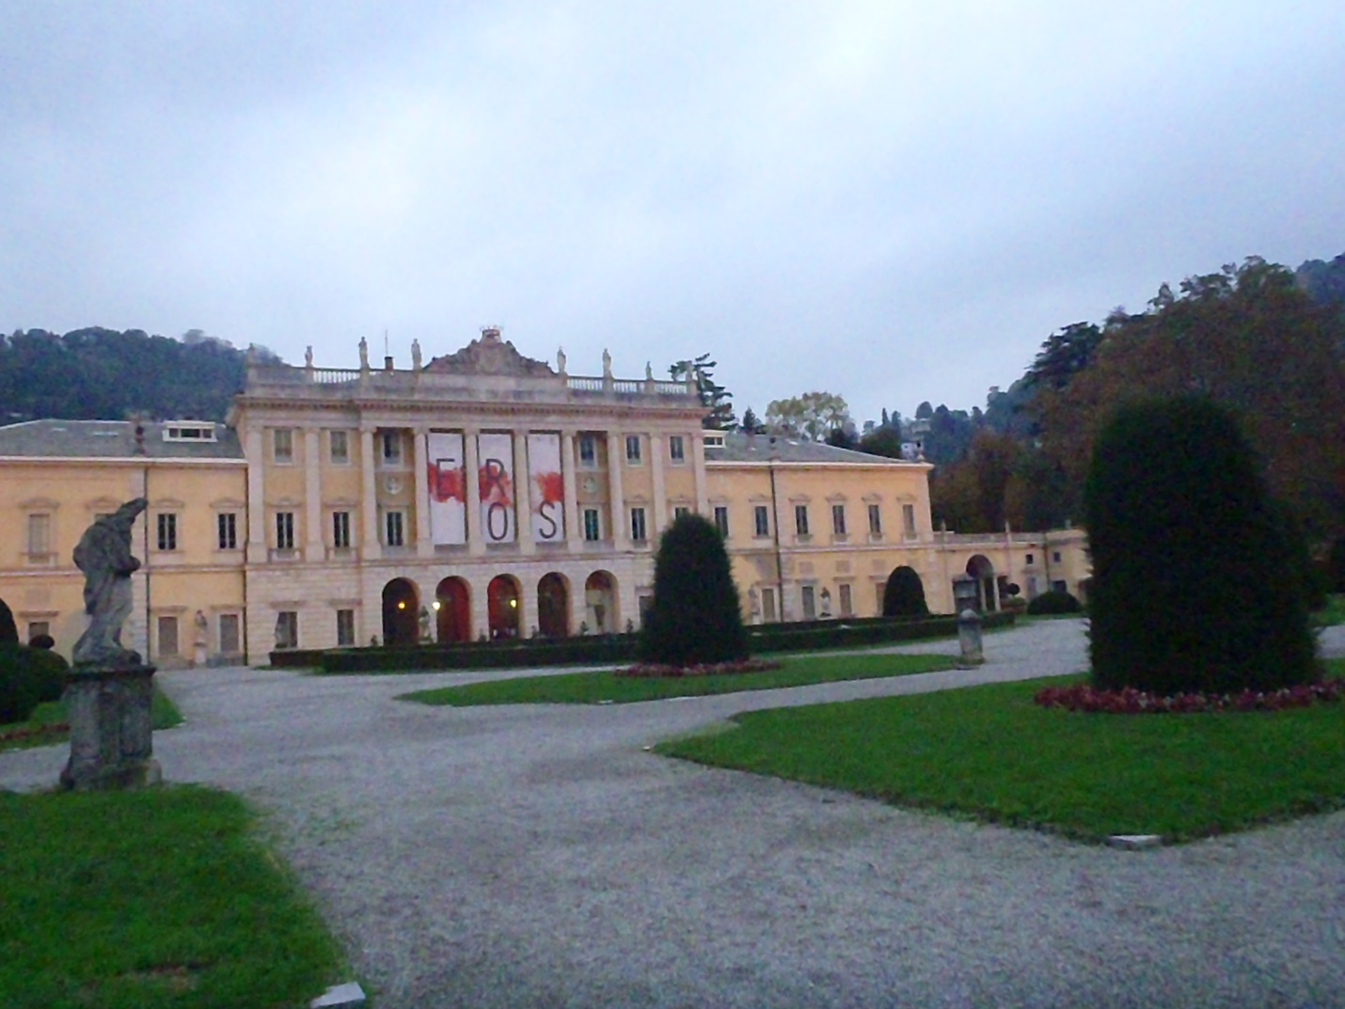

Pic#2 shows the art gallery on the waterfront with an alluring exhibit which was almost closing my first night and I was otherwise indisposed (probably won't find the space to elaborate but all the more reason to ask me the next time I see ya) on the second so I never made it in.

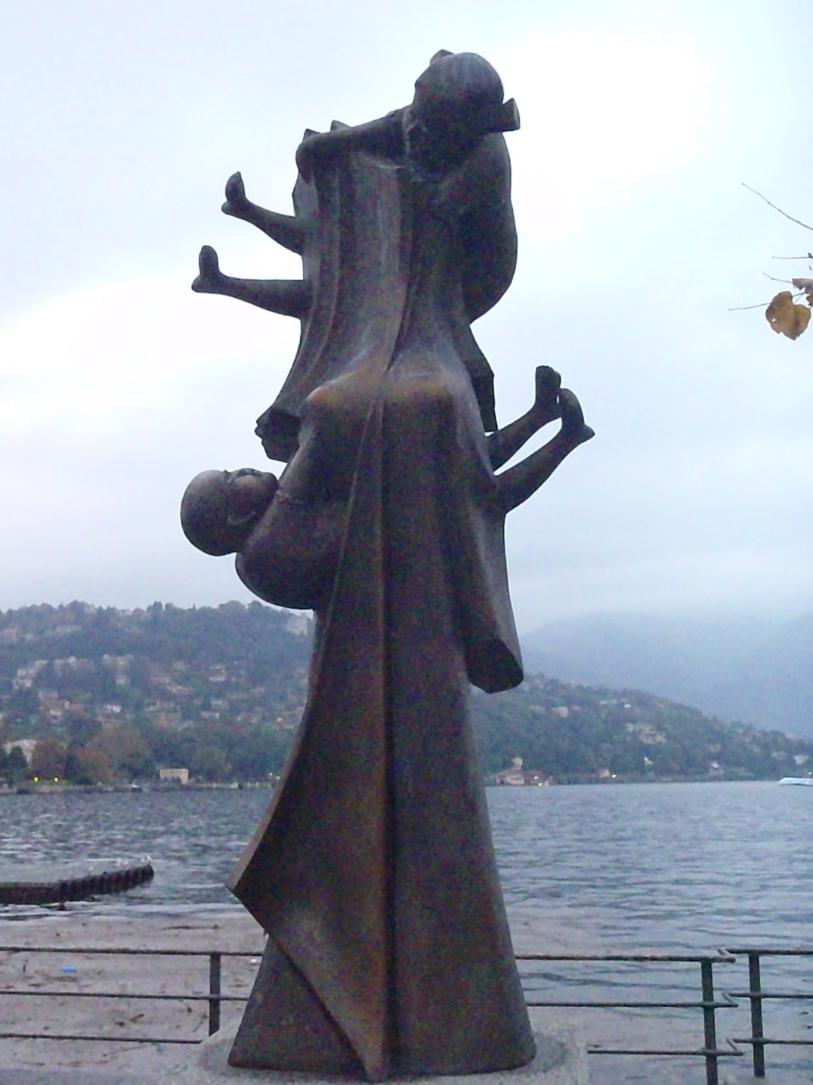

One of the more fascinating sculptures (pic#3) captured my attention the longest as I wandered the well-manicured lawns walking from statue to fountain to, well, you get the idea. One post hardly does it justice so I tried a two-for-one in the next photo (pic#4) getting a fountain up-close and the large lake fountain in the background.

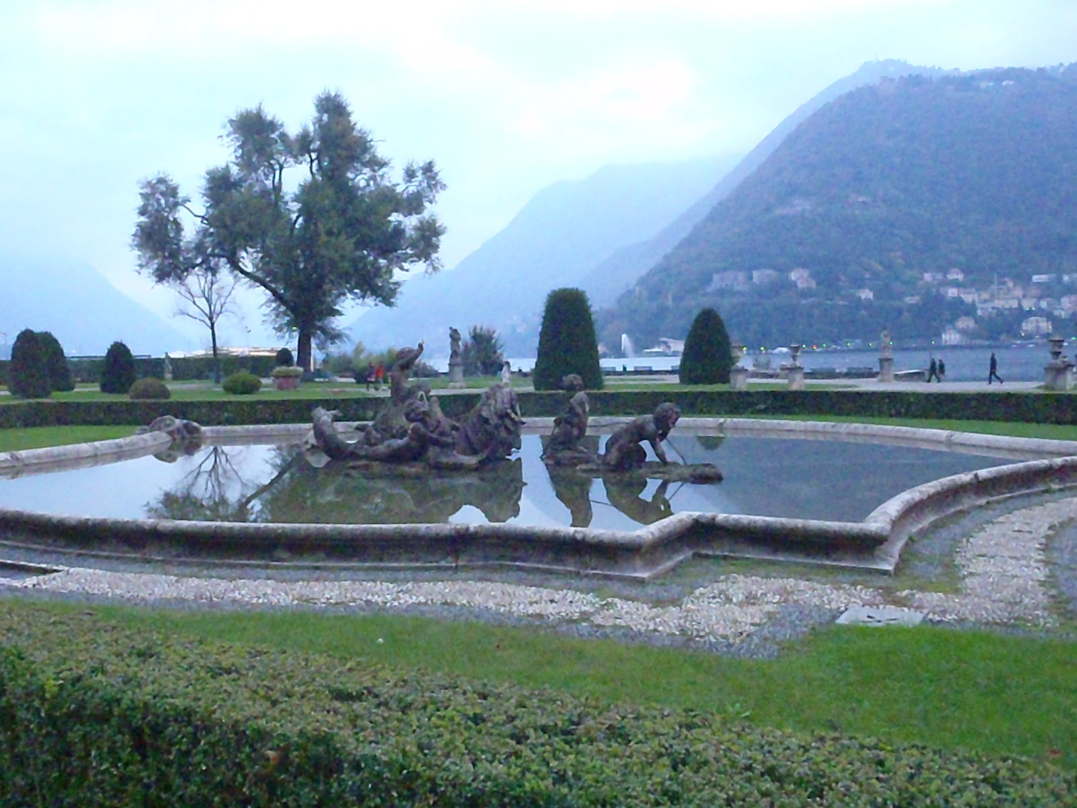

The final 2 pix kinda identify Italy as winsome yet regal...the entire trip had become an oscillatory exploration of a national identity. It was still fun...

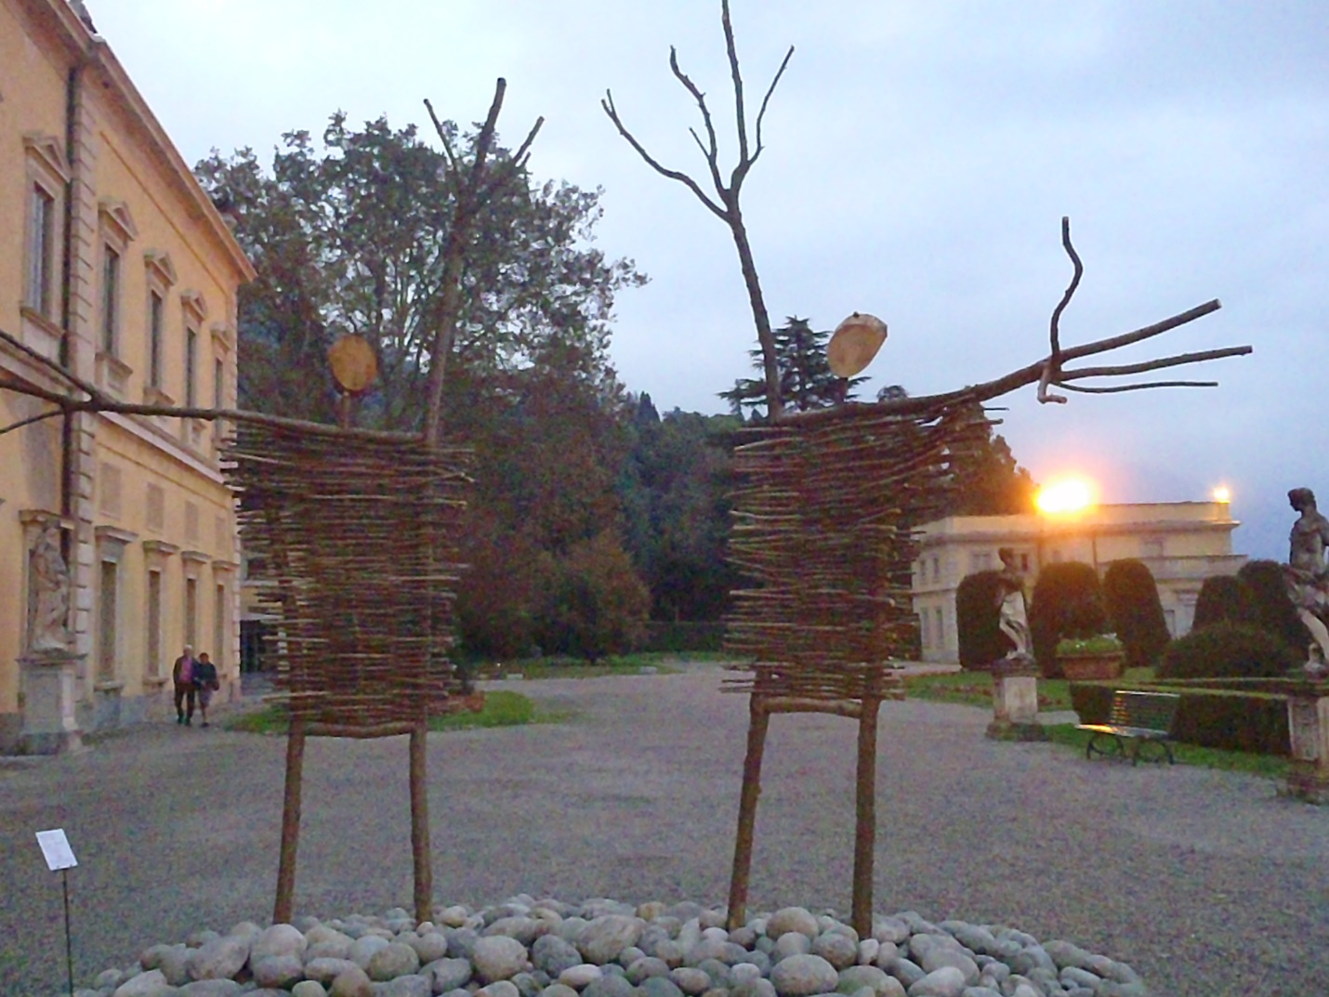

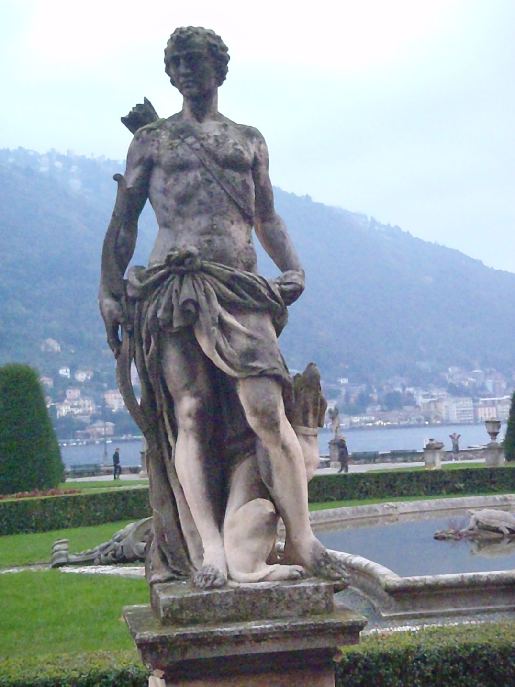

As I sat drinking a birra with shot of tequila (dispensed by a doubt-filled server), I considered my options for the next day: a bike ride to Switzerland, a hike and ride on the funicular, a boat tour or train to another part of the lake, they all sounded fun (a little been there, done that) but somewhat limited by the weather though who really cared, in a couple of days I would be in the relative comfort of Milano and a mere 26-hour travel day from home sweet home. Thoughts circling like the planes taking off and landing on the lake...hmm, another shot. Okay, if it's X amount or less, I'll do it. Screw the "nice suit of clothes" I'd promised myself. I mean, when would I ever wear wing tips and a sweater vest in Santa Cruz?

Next up...an aerial tour of Como: "Um, Marco? I'm not really interested in the Branson estate or where George Clooney lives or what Bond flick was filmed there...just fly the plane. Wait, is that Catherine Barkley rowing to towards her masochistic fate or Charles Barkley looking for his drive?"

As soon as I booked a 9:30am aerofloat tour, I started losing sleep. No matter how much you convince yourself that everything is going to be okay, you're still alone in a foreign country making decisions on-the-fly so to speak and every "bonk" in the night sends your imagination into a tailspin: the rain on the shutters an engine stuttering mid-flight, the machinations of the mini-fridge the whine of a plane on an un-planned descent. By morning I was skittish as a housecat after a night in the animal shelter, my anxieties like dogs howling in the night and me ready to scramble up the nearest tree.

The young pilot who signed me up the evening before hadn't shown up and the small office staff thought it laughable that he would be in for a 9:30am flight. An older pilot with close-cropped, steel-grey hair and piercing blue eyes approached in cargo pants, work boots, and a beat-up, non-aviator jacket. Now here was my kind of pilot, the type that can get you in and out of a jungle with contraband, if necessary. For me it was like trading Anthony Michael Hall for Michael Douglas…more 80's references to come.
"My name is Marco. Do you fly?"
"Um, no."
"Not yet," ha-ha, "in a half-hour, we fly!"

Of course, a half-hour in Italian means whenever the fates align which is just a smidgen more prompt than "island time". After the pilot change and waiting out the pre-flight checks, instead of a tree, I climbed into the training seat of the Piper Cub, following the needless advice of the pilot: "Don't touch anything!" We taxied towards the water only to be waved down maniacally by the mechanic. Evidently, all my lost sleep was justified.

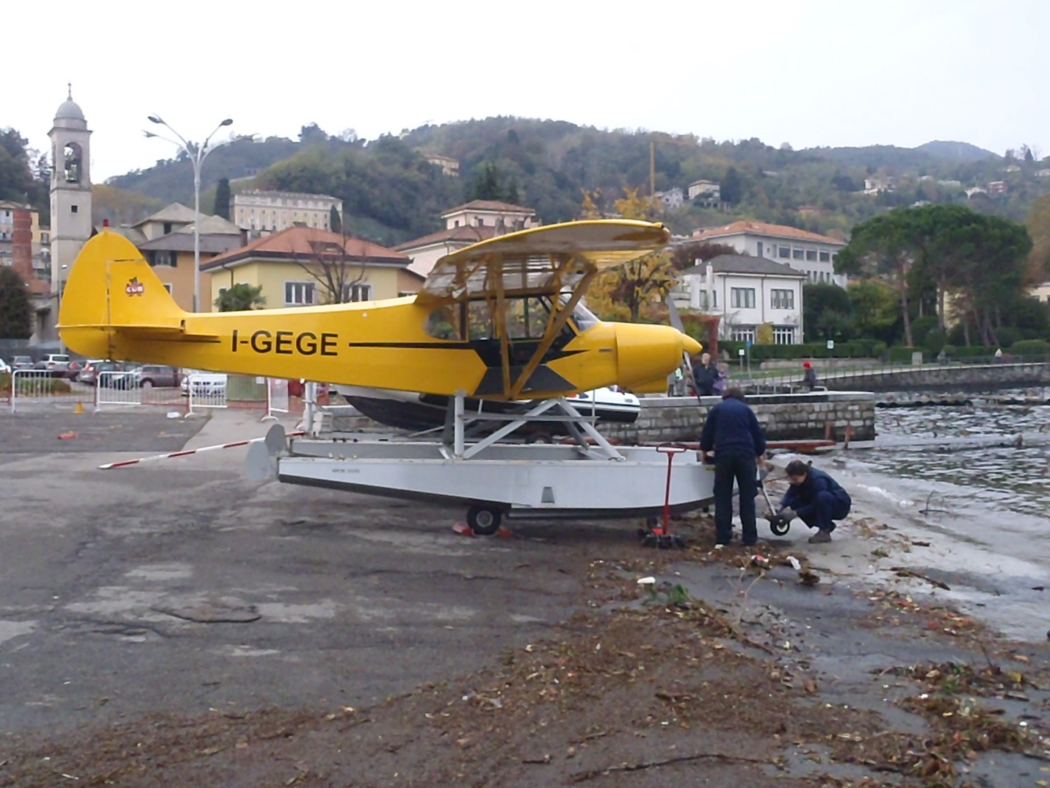

Even though I had to get out of the plane, a flat tire didn't really bother me much--I can swim--did we even need a tire? Now if a wing or pontoon were to come off, I probably wouldn't have got back on the plane. Did I mention this is my first time in a two-seater? Not to mention, a plane that takes off and lands on the water and after hours of being forced to watch "Fantasy Island" by my sister (I got "Dukes of Hazzard" on Friday in the trade) it was a fantasy on an ur-island befitting of Mr. Roarke and his aboriginal love child, um, I mean Tattoo, "bossth".

I'm not sure where I was going with that...back on the plane, the tire fixed, we finally got out on the water. What a great feeling...floating along a foreign lake as so many before. It made me want to put on water skis until Marco flipped a few switches and headed back for the ramp and I started to wonder if my rate was based on actual air time or if I'd spent my wad in the parking lot...wouldn't be the first time.

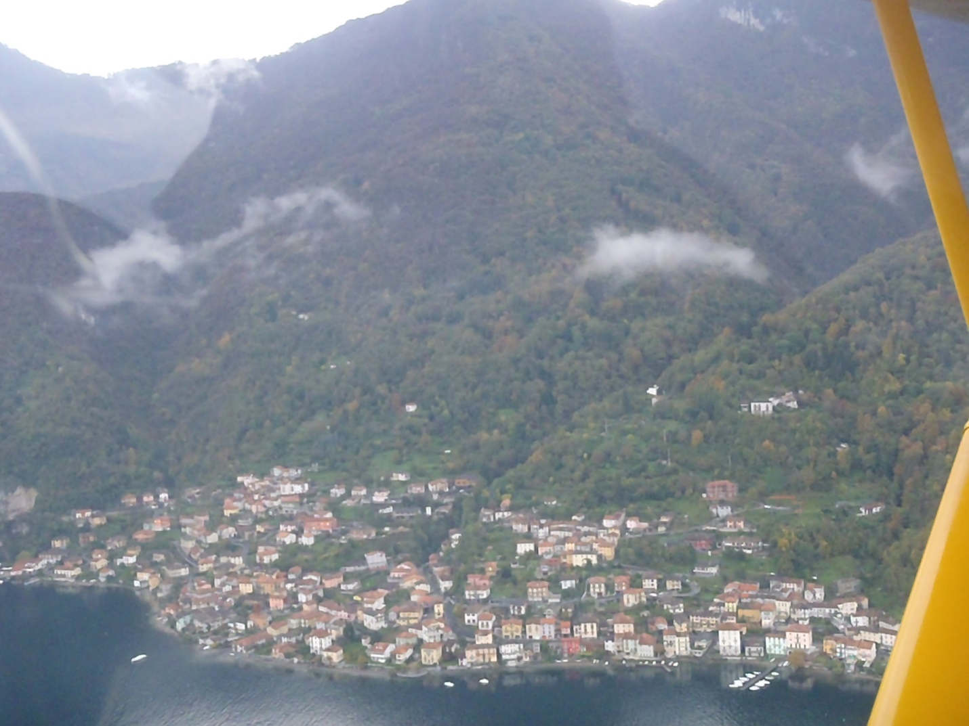

The second hold-up didn't even get me back out of the plane and after the thrilling...I mean f-ing thrilling take-off we were in the air. The lake is shaped like an inverted "Y" with the town of Bellagio in the money spot where the legs come together, very typical of a Vegas-themed resort...oh wait, you mean the Venetian, Caesar's, Bellagio came after Italy? If you say so but my money's on Vegas. The next pic gives you a peek from one leg of the lake to the next.

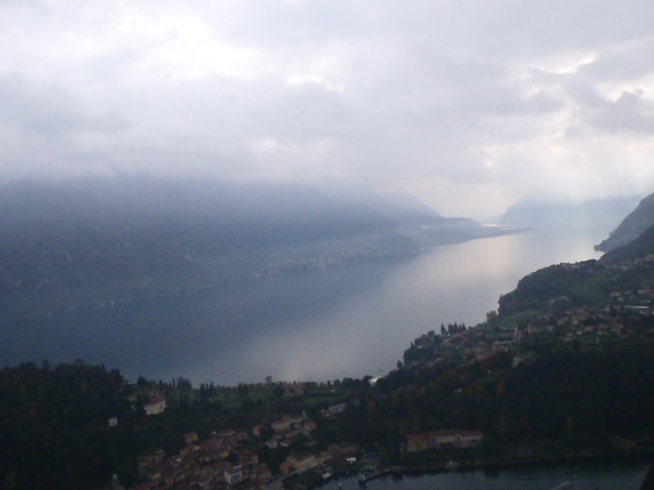

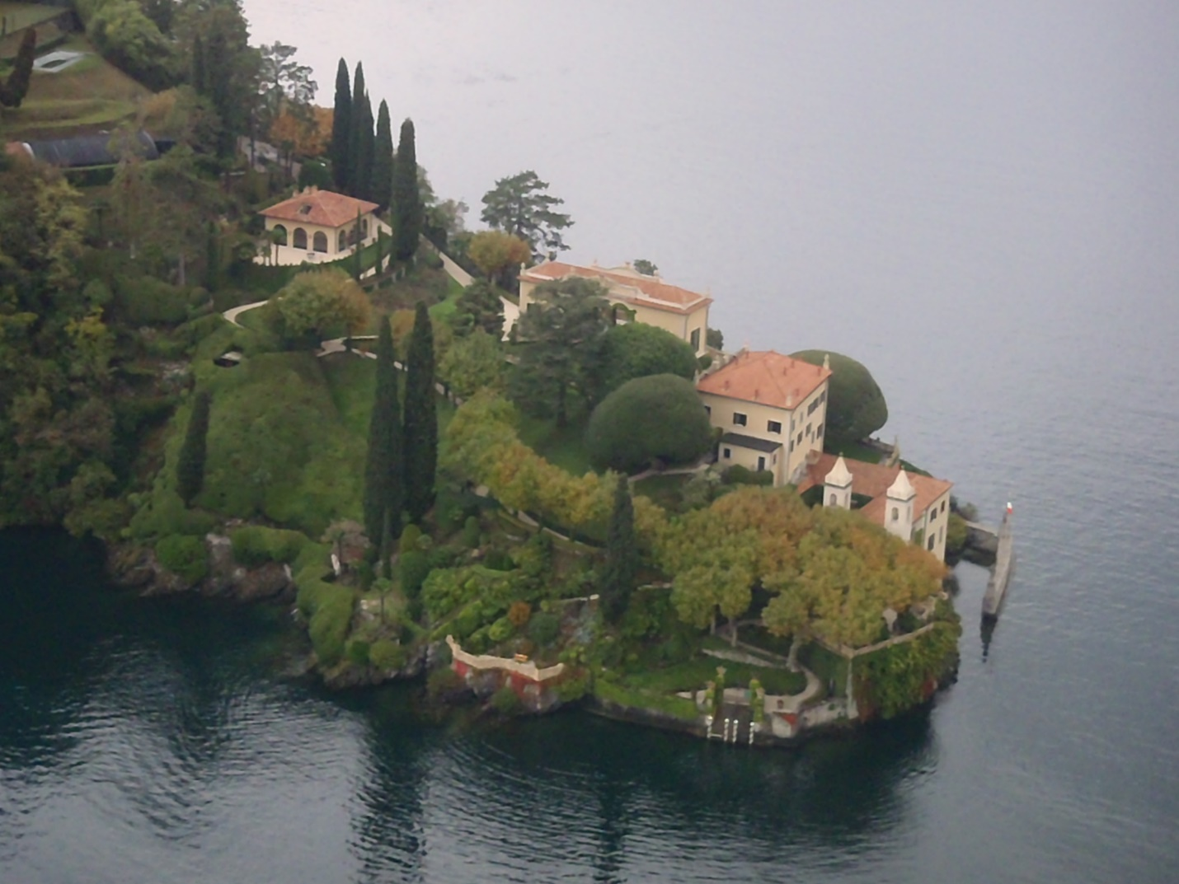

We circled back over famous estates (above was featured in a James Bond film) and the city of Como with more amazing views and thoughts of my next time through wondering with who. The landing was not near as thrilling as the take-off despite all the noises coming from the cockpit controls and soon enough I was, again, back on terra firma (as you can tell, I really like this Terra chick) with the plane intact (final pic).

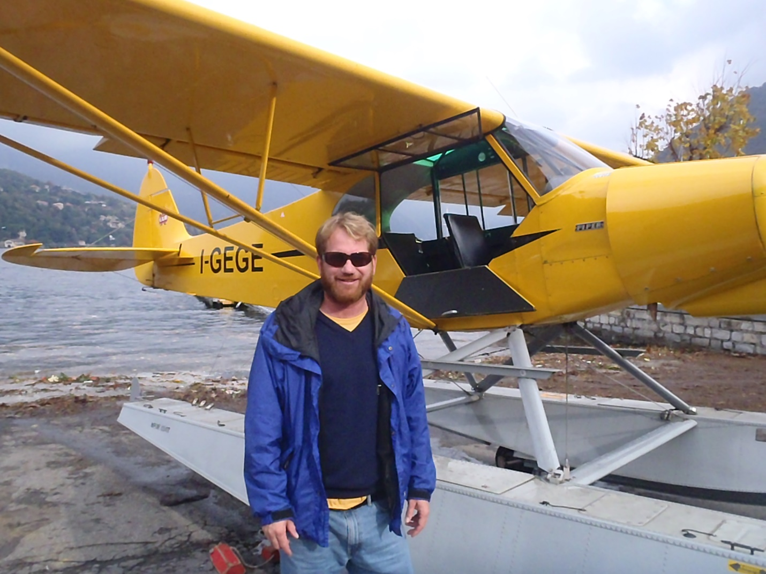

Somehow, the flight signified a sort of end of the trip as if landing had brought me a little closer to home. These thoughts were magnified that evening at the aptly titled American Bar (free apps with a drink) where I was the only American. Of course, I befriended the bartender/tattoo artist and the petite blonde server he comfortably spanked as she made drinks behind the bar. They only receive a small percentage of American music exports so I turned them on to Primus, Phish, Devil Makes Three, and taught them the value of a sliver of chocolate from the foothills of the Rocky Mountains--US style.

Beer note: I can't find it on-line because there are other beers with a similar name but if you make it to Como make sure to ask about the Old Jack Chocolate Stout Toasted Black from a small local brewery...it left me very toasty indeed.

A great finire to my journey "in-country" as I staggered through the maze to my hotel room and a morning train ride back to Milano where it all began.

