Trieste, way too much to digest ya…and I'm not just talking about my first experience with an authentic Italian calzone (pic#1).

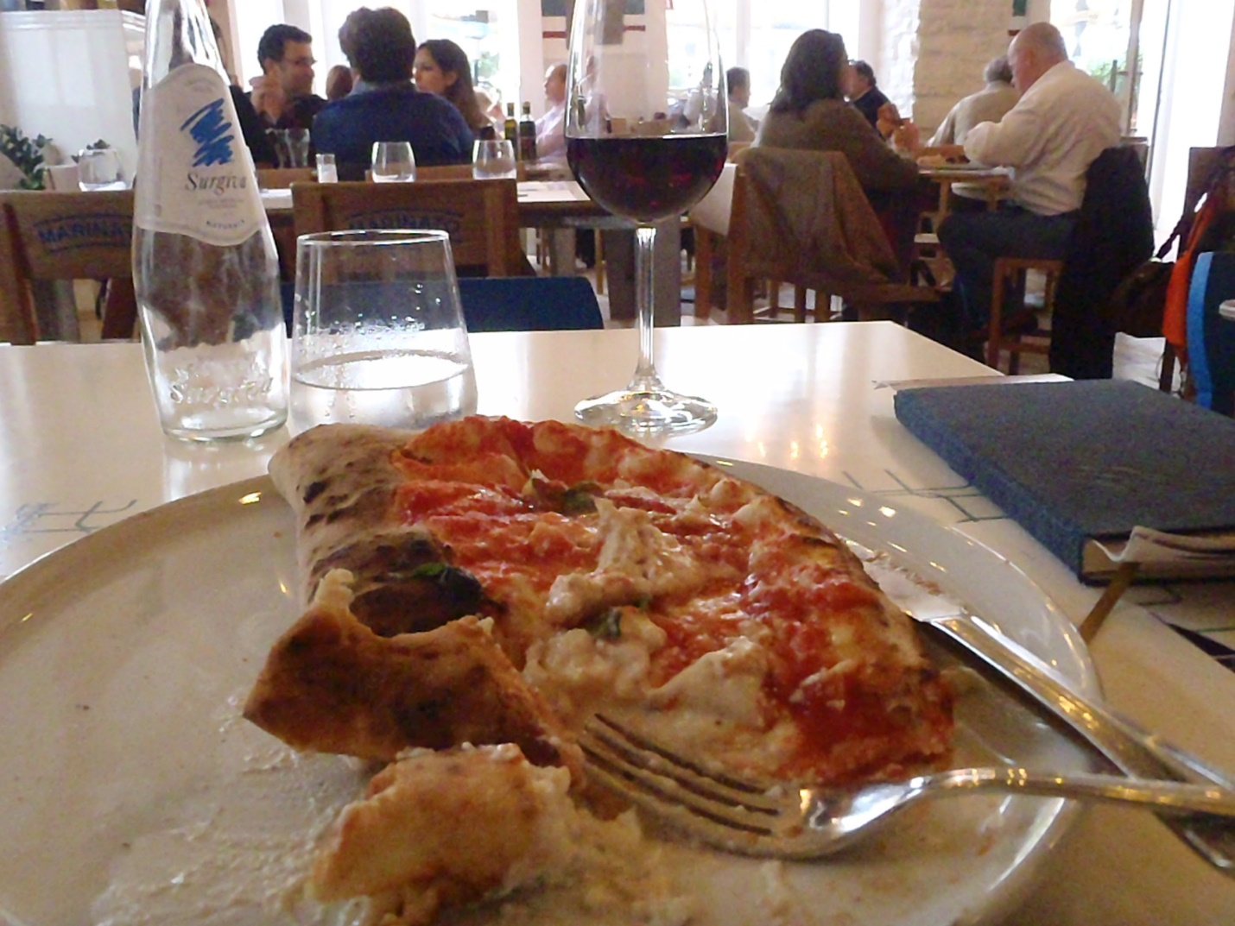

The staples on my trip had been ravioli, paninis and pizza, but I hadn't tried a calzone. I'm not sure if I ate it or it ate me. It was like drowning in a pool of hot, bubbly cheese before eating your way to the relative safety of the doughy crust where I beached like a toasted whale with no more sustenance required for the next 16 hours.

The city of Trieste is unique in its geography and cultural history and I already sound like a dork in a bow tie at a cocktail party expounding on something they'd just read on wikipedia. I noticed more and more as I travelled north that a lot of the inhabitants didn't consider themselves Italian and the ones that did, did so reluctantly. Trieste is at the crossroads of Latin, Slavic, and Germanic cultures, and was even an independent city-state following the second world war. It had been a part of the Austro-Hungarian empire of the Hasburgs, it was occupied by the French three times during the Napoleonic wars, and to this day contains a large Serb-Croatian population. In the 50's, Trieste was divided into Zone A which became Italy and Zone B which went to Yugoslavian administration with smaller sections going to Croatia and Slovenia. It wasn't until 1975 that the final border between Italy and Slovenia was established. It is an inviting spot for all kinds of itinerant travelers (pic#2) where progressive idealists had been replaced by opportunistic realists--arrrr!

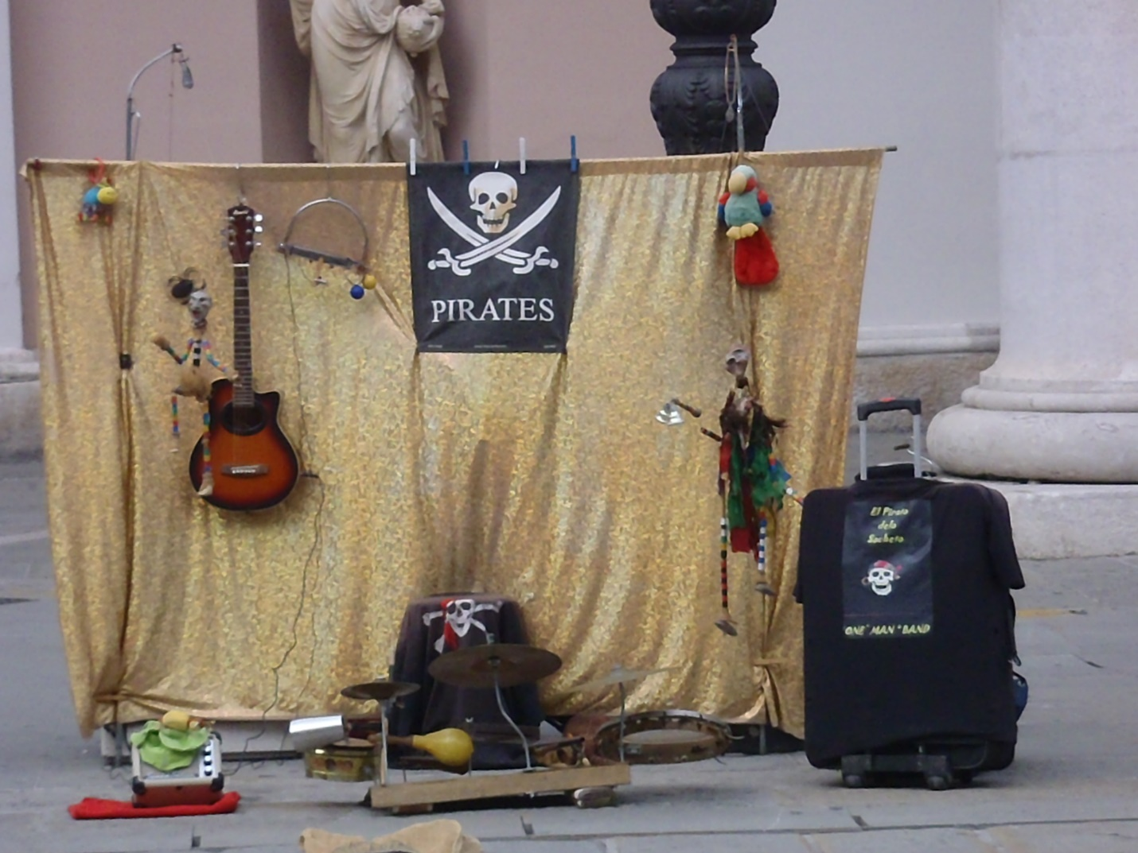

Its location made Trieste an important Mediterranean seaport for all of the above regime transitions. It was easily the furthest eastern city I visited on the trip (and in my life) and barely seems to fit within the Italian borders. It lies on the Gulf of Trieste at the northernmost tip of the Adriatic Sea. I didn't get a chance to swim here as the accessible beaches are located a little further down the coast in Slovenia and Croatia. A fellow traveler recommended the islands off the coast of Croatia as a beautiful and affordable alternate to their more ritzy Italian counterparts of Sardinia and Sicily. Alas, it was another hour or so further on a regional bus to reach these areas so I opted to stay and explore the old city and seaport of Trieste instead…and I certainly didn't regret it.

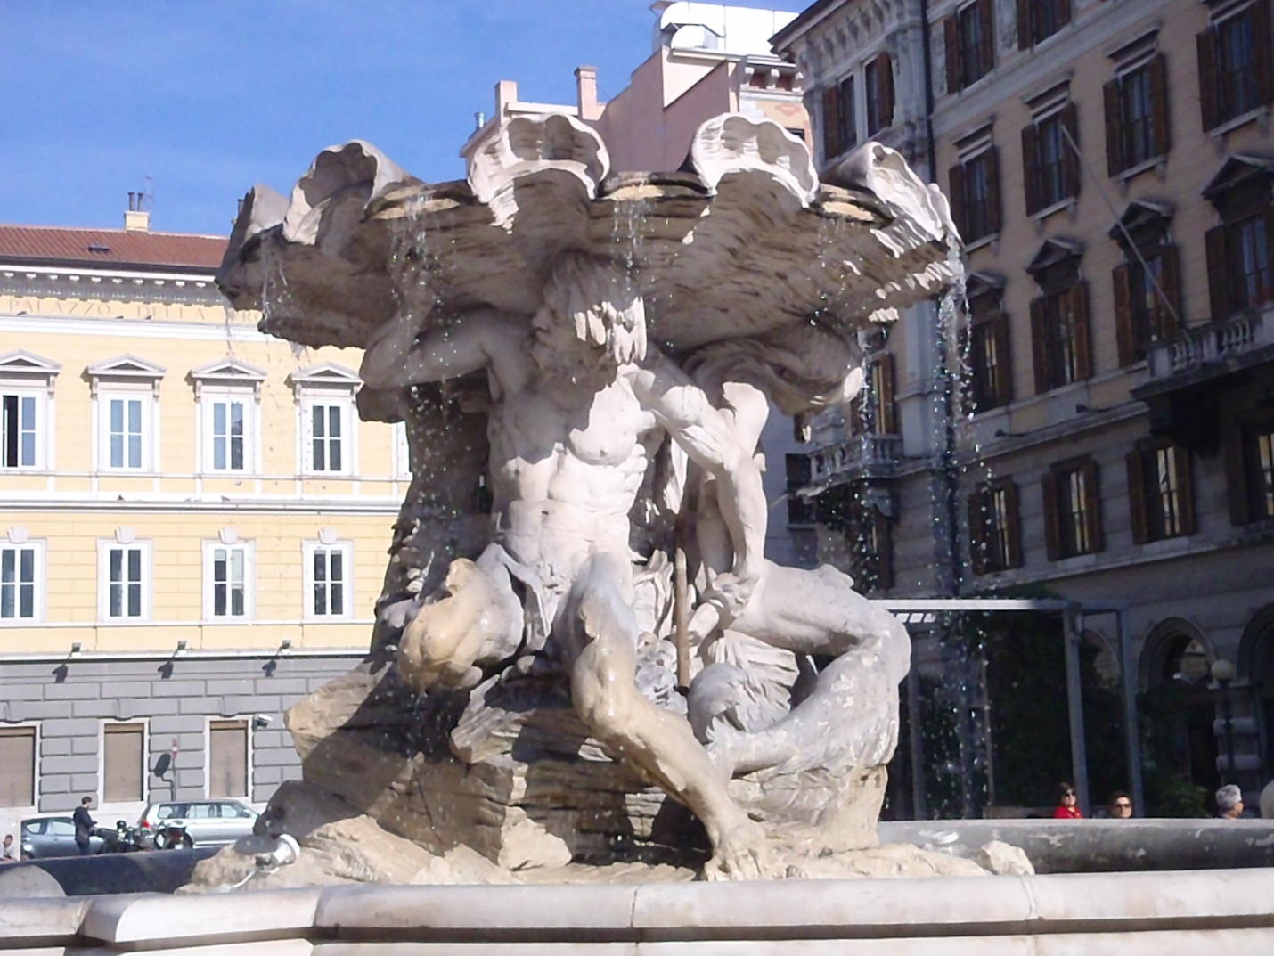

I bumbled around with my backpacks in the initial search for the B&B and finally resorted to my second and final cab ride of the trip but not before I came across another of my favorite random masterpieces (pic#3). Here, two men and a woman are seemingly supporting the weight of the world. The male here is also supporting his female counterpart and I already feel like a dork in a bow tie given to preposterous interpretations of a simple stone-carvers vision.

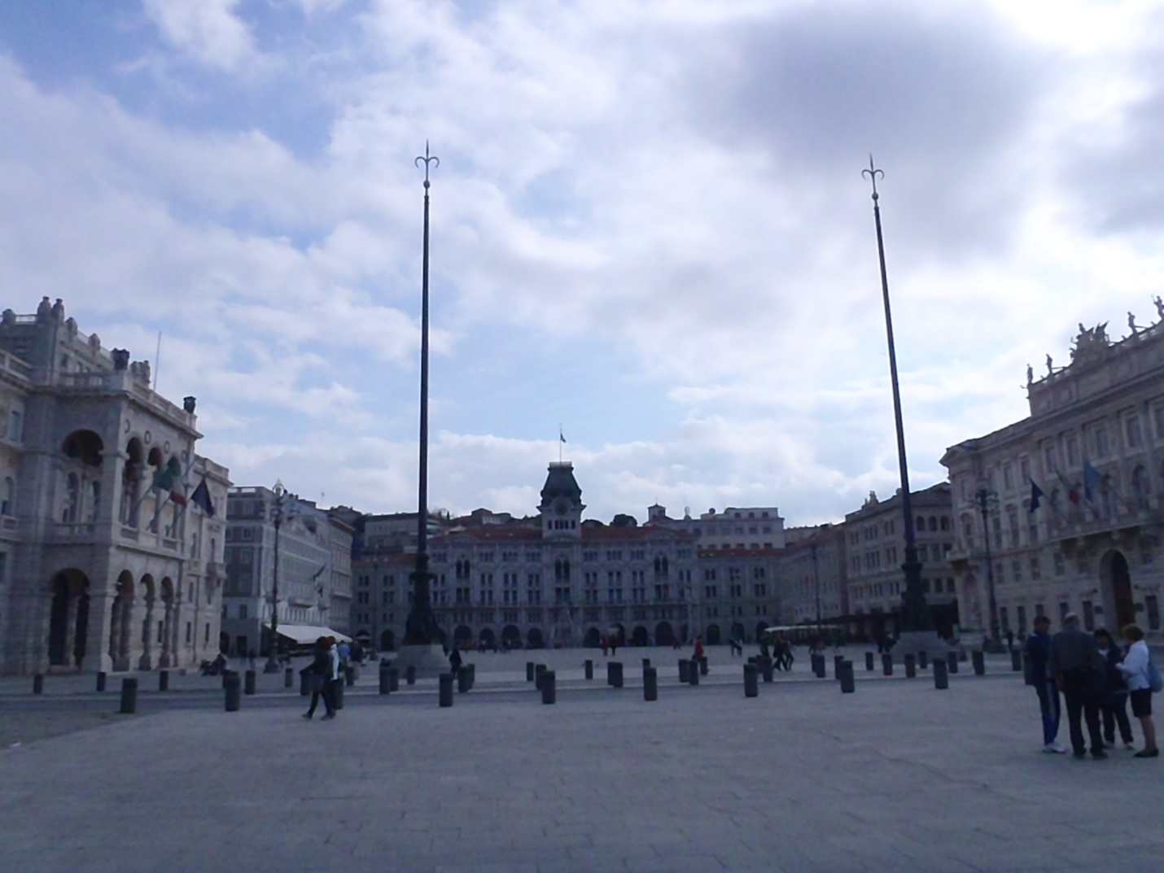

After dropping my bags, I set out to the old town center...for whatever reason they didn't refer to it as el centro here but it was no less magnificent (pic#4). The Piazza Unita d'Italia is the financial and cultural center of the city. I highly recommend googling pix of this place at night...it's lit up in a hallucinatory exploration of cross-cultural architecture that inspired my second dip into the candy jar.

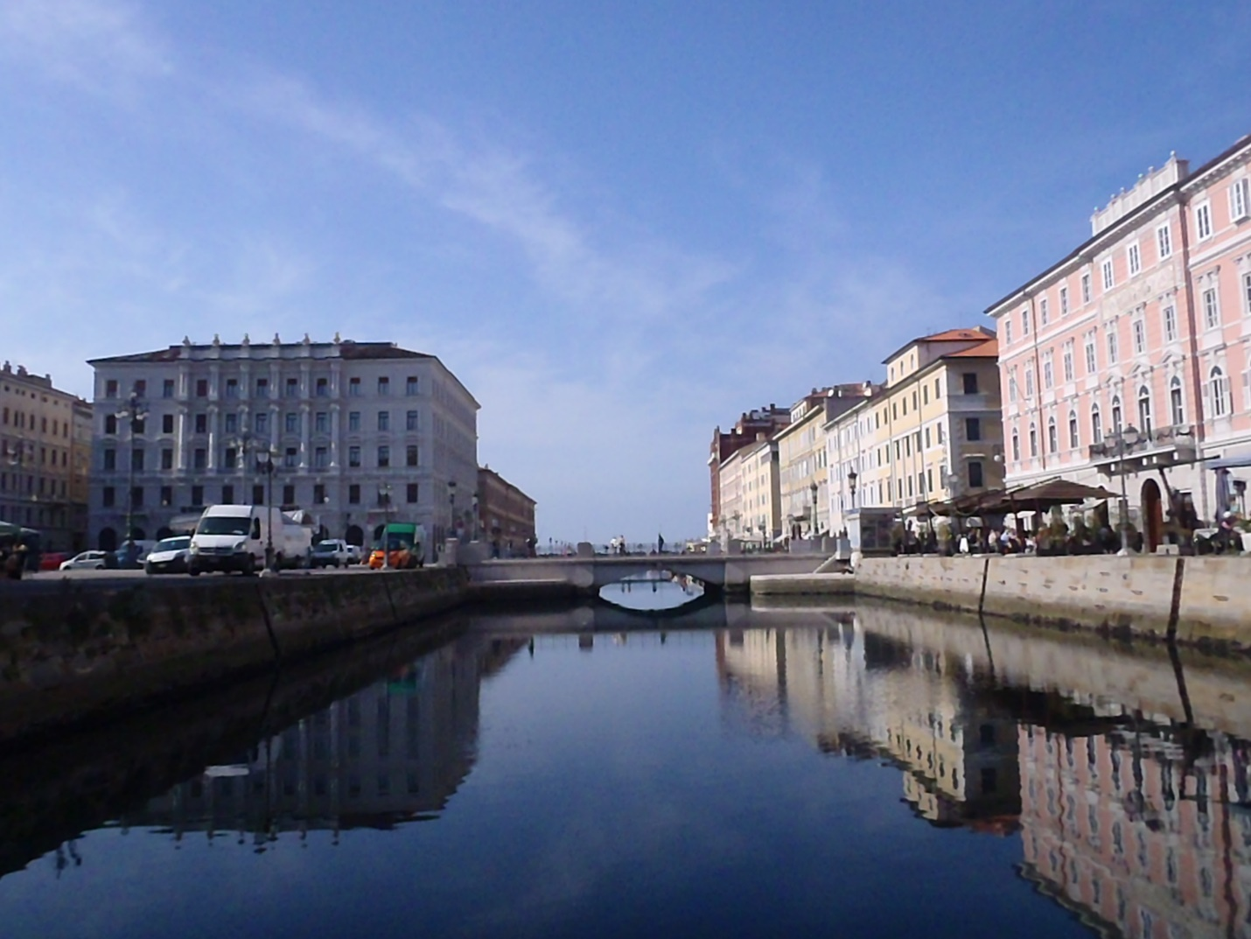

I also managed a Guinness or two as I'd entered the land of Joyce and even if he preferred white wine spritzers, I happily toasted (mmm, more toast) the homeland he deserted but wrote about in anonymous flats along these streets. The B&B has a great location along the grand canal of Trieste (pic#5) where Joyce lived and drank espressos while reading Italian newspapers trying to solicit English language students. The walkway in the picture is called Passagio de Joyce and for me it served as a bridge to another time when artists weren't so much malcontent marketeers as egregarious egoists.

And, I, a tourista of tongue-twisters looking forward to a day of chasing Ulysses*...arrivederci.

*I am in no way endorsing the newest overly-acclaimed Cohen Bros. flick where the degenerate protagonist chases a cat gratuitously called Ulysses...save your time and get the soundtrack, if you must, and I'm already sounding like an overweight dork in a bow tie straining the springs of his easy chair.

Editor's note: The quasi-author of these diatribes was so high on his horse (wait, not exactly what I mean) that he made a spelling/vocabulary error on the previous page. He meant "egregious egoists"…blatantly bad egoists…not "e-gregarious egoists", which sounds like some kind of on-line dating site for people who can't get their head out of their ass. How embarrassing. He sincerely apologizes for intimating that Leopold Bloom was the result of some kind of cyber-stalking stream of conscious hijinks.

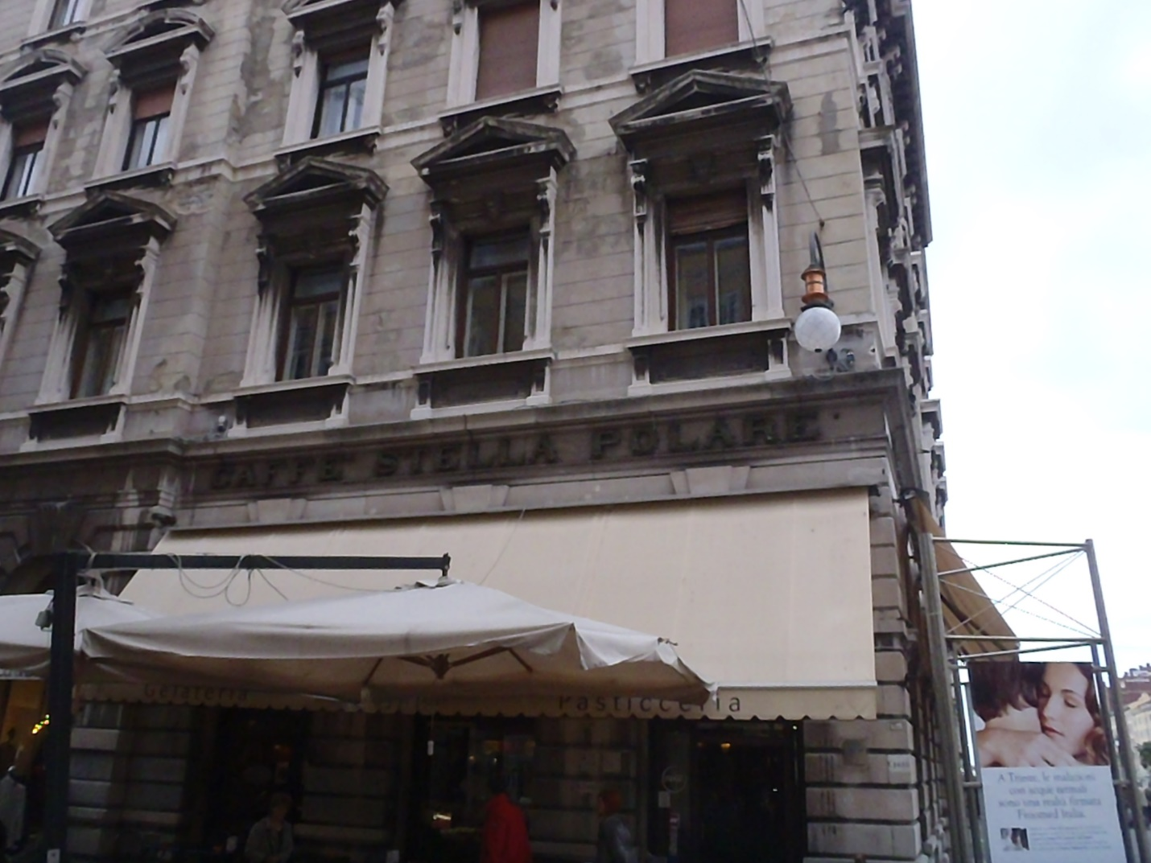

Until I walk along the banks of the Liffey, my own Bloomsday will always be October 19th. It started with an espresso in a café (above pic) Joyce frequented and actually ended here as well with a stoli white russian—how's that for circularity? Listening to the older gentlemen at the café bar discuss politics and futbol (I mean, what else could it be), I felt a shift as if the lights subtly dimmed in the movie theater transporting me to a place partially real and partially the product of the imagination. I smiled as my heart not-so-subtly exploded from the caffeine injection and I walked in a daze out to the street and met my host for the day (speaking of bow ties).

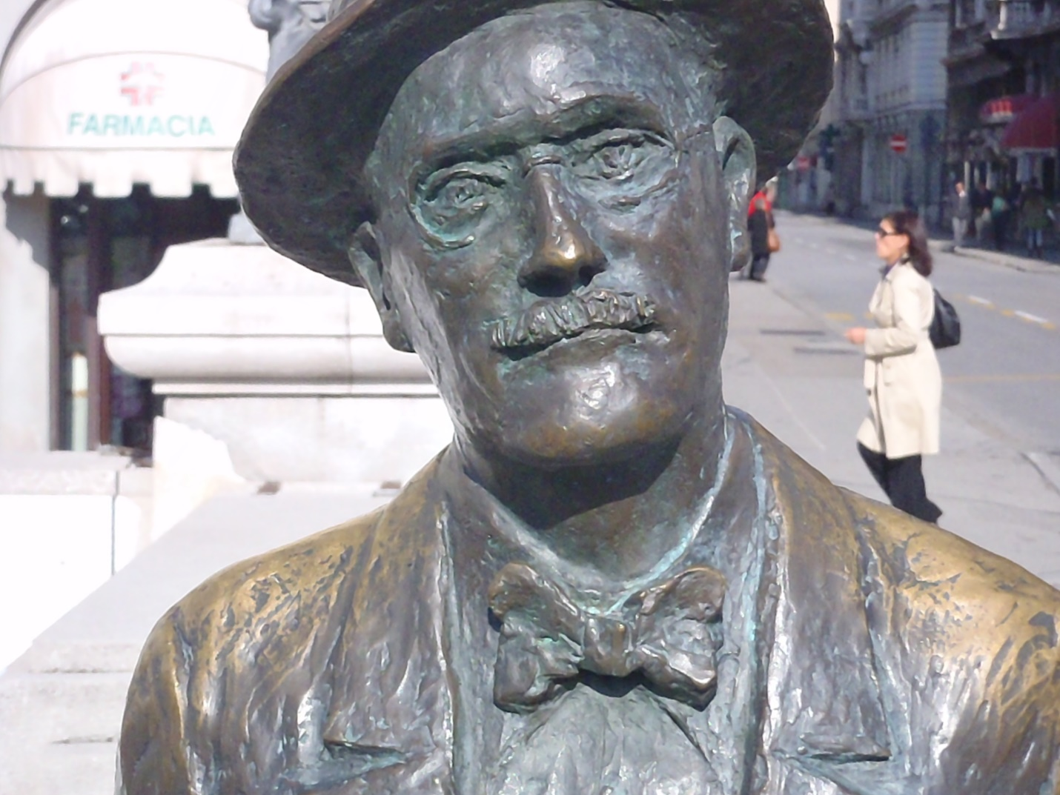

A plaque next to the statue read: "...la mia anima e a Trieste..." (Lettera a Nora, 27 Ottobre 1909) James Joyce 1882-1941

The great part of the self-guided tour is you get lost and find places in-between the places that add to the mood of the tour. In between the flat where JJ (so much less formal after you've spent a day with a ghost) wrote some of the stories of Dubliners and where his son, George, was born and the apartment where he re-wrote Stephen Hero and had his daughter, Lucia, sat an antiquarian bookstore (next pic) complete with rickety floorboards and old men discussing state secrets in hushed tones amongst stacks of disorganized tomes. It felt a little more Dickensian than anything else but I refrained from testing my companion's literary sensitivities by mentioning it.

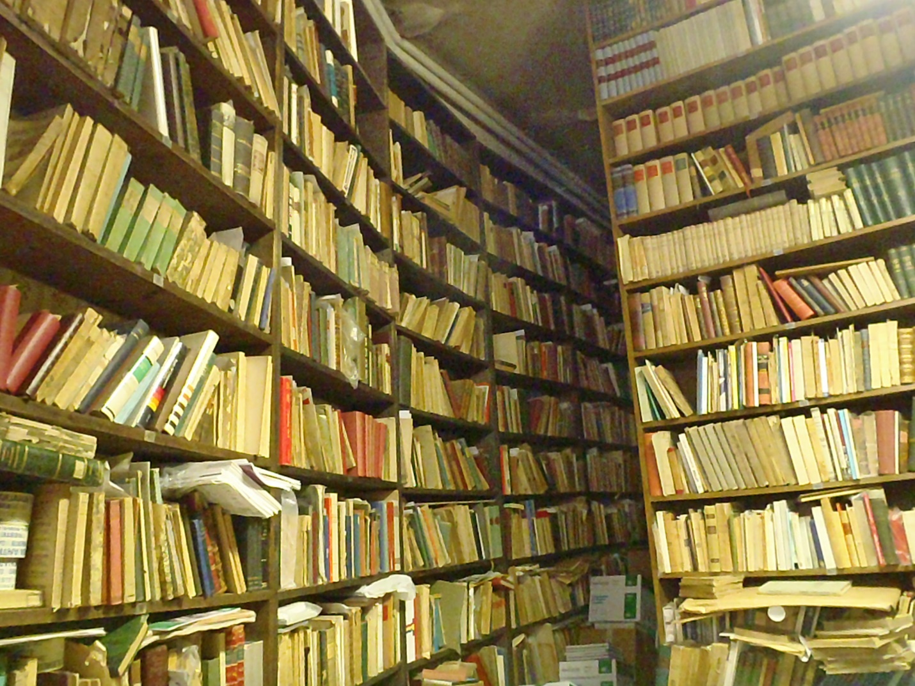

All along the route, the official spots of the tour were denoted by plaques with JJ identified by name, of course, but also other artistic luminaries that called Trieste home at some point in their careers.

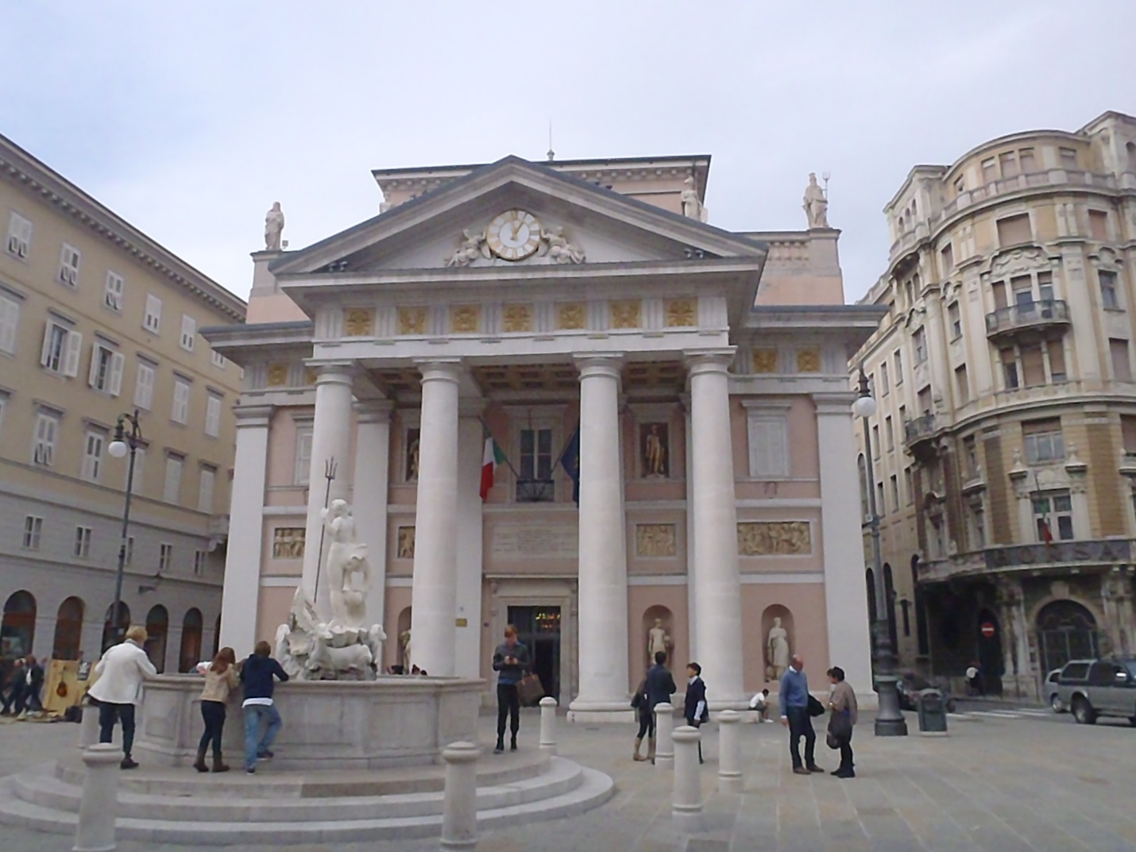

Here’s a pic of the Teatro Verdi which included the plaques of others, as well: Umberto Saba, Itala Svevo (a model for Leopold Bloom), Rainer Maria Rilke; where they all attended productions of the theater's namesake. Hopefully, I'll know more about these three the next time I see you. More and more ghosts were collected as I walked the tour through all 22 sites: Nora Barnacle, Stanislaus Joyce, Eva and Eileen Joyce, Frantisek Schaurek, Almidano Artifoni, to name a few.

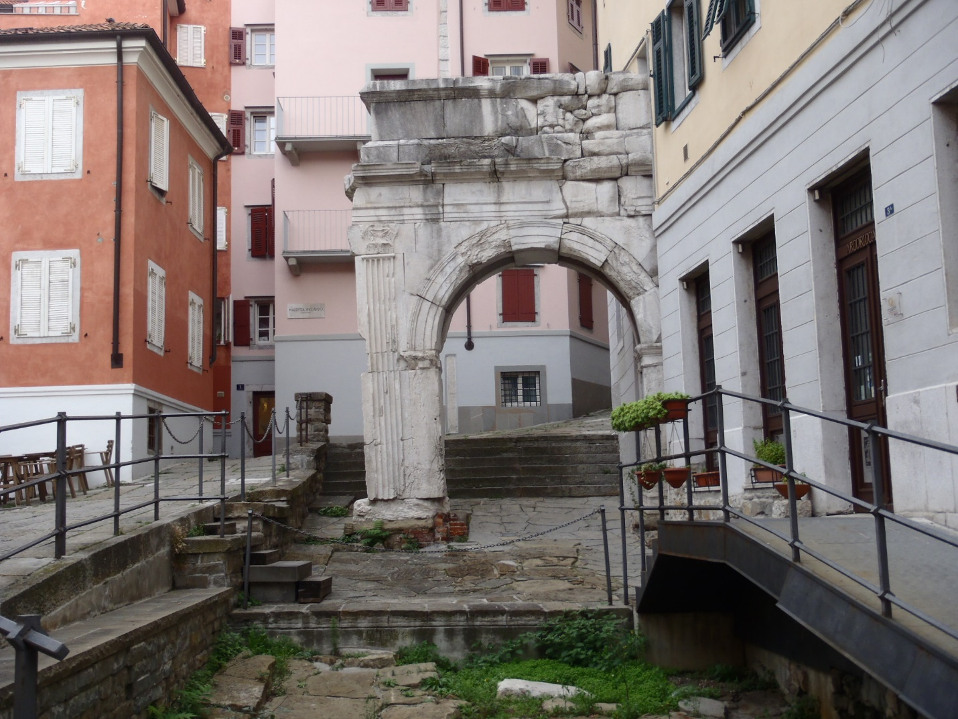

I took pix of all the sites and so much more and as we meandered through the narrow streets of the old city until we came to Richard's Arch. We stood side-by-side looking at the remnants of the Roman ruin even as a more modern building conducted business as usual. We embraced the silence of the secluded spot and all the metaphors for our worlds as one bridges to the next and then Leopold headed home for Molly's embrace as I took flight for the sun (pun intended). Actually, I'm no Stephan Daedelus so I found the first café and ordered a glass of wine very much a part of this earth. I still spoke limited Italian and the proprietess spoke no English but we laughed and drank to each others health and incomprehension.

I look forward to that day when I step back into the pages of Joyce…with the tiniest extra bit of comprehension.

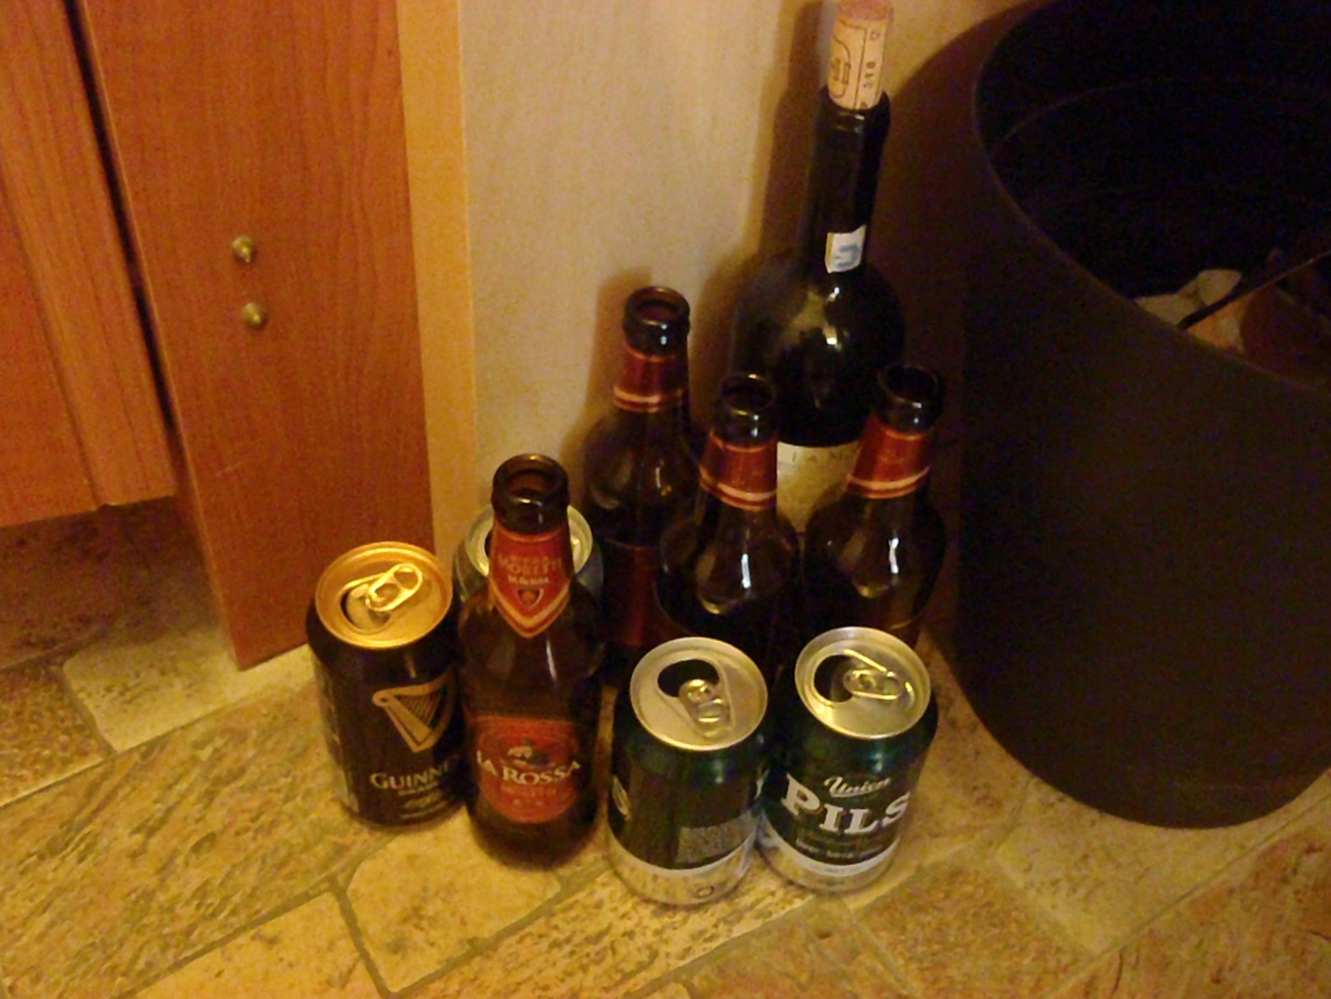

After walking with ghosts and drinking with goblins, my last day in Trieste started with a hangover. I call this pic, “Leaving Trieste”…of course, the bottles and cans consumed wandering the streets at night are all unaccounted for which would not come as much of a surprise to anyone who tried to teach me accounting. The last day I spent wandering with a Bloom-ing hangover as I walked in the opposite direction of my previous day’s adventures. I'm okay wandering amongst ghosts of years past but ghosts of the night before make me a little uncomfortable.

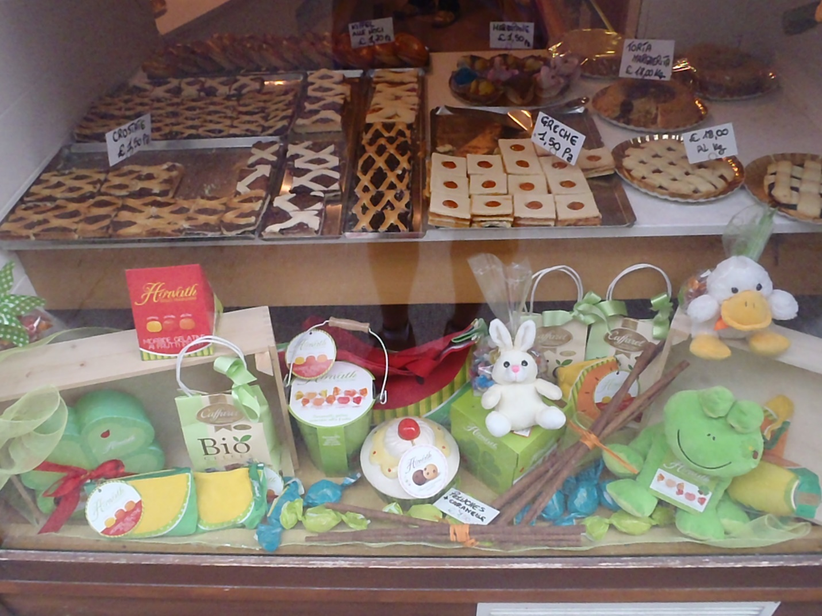

Unlike the previous day, the last day's meanderings had no guide…in fact, I don't think you could even call it self-guided as I tried to absorb the myriad identities of the city. I didn't absorb any of the above pastries but I've had many requests for food porn so I thought I'd give the people what they want. From, here though it's hard to determine the best three shots to summarize the city that's like opening presents on Christmas day. Do you start with the stocking stuffers or do you go straight to the tree and open the biggest box with your name on it? Well, like a kid on Christmas morn, I want a little of everything and only shared the best.

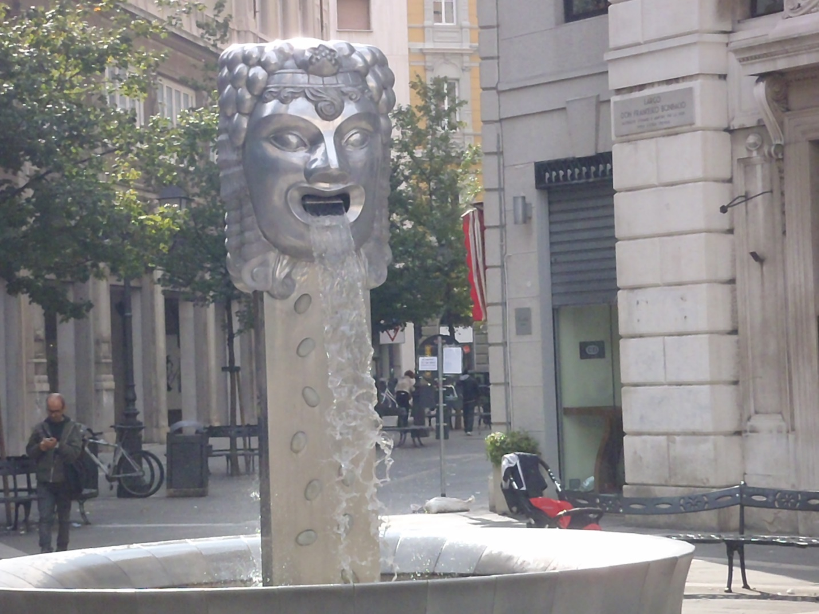

Okay, okay, you get it...I wrote this around the Christmas holiday. Well, another fountain without a name is shown here. Although the subject may pre-date the classic fountain from day1, I'd say the materials and design are more modern (yes, I put the bow tie back on). There were so many other images of interest: sex shops (again, giving the people what they want) & sexy shops, candelabras & hippy art, street scenes & seascapes (final pic), and they all pull you towards the great escape.

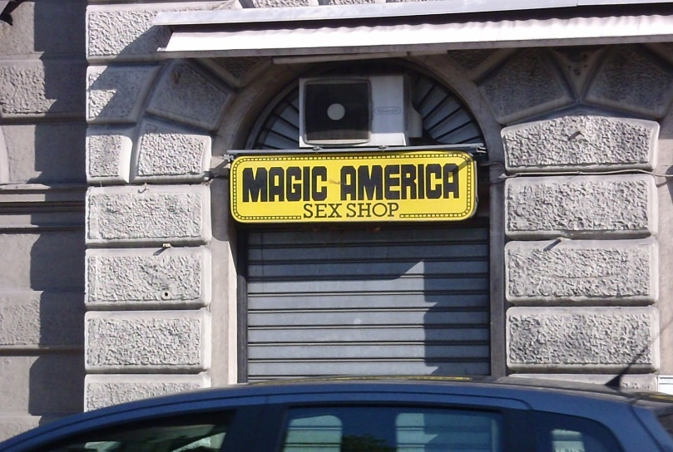
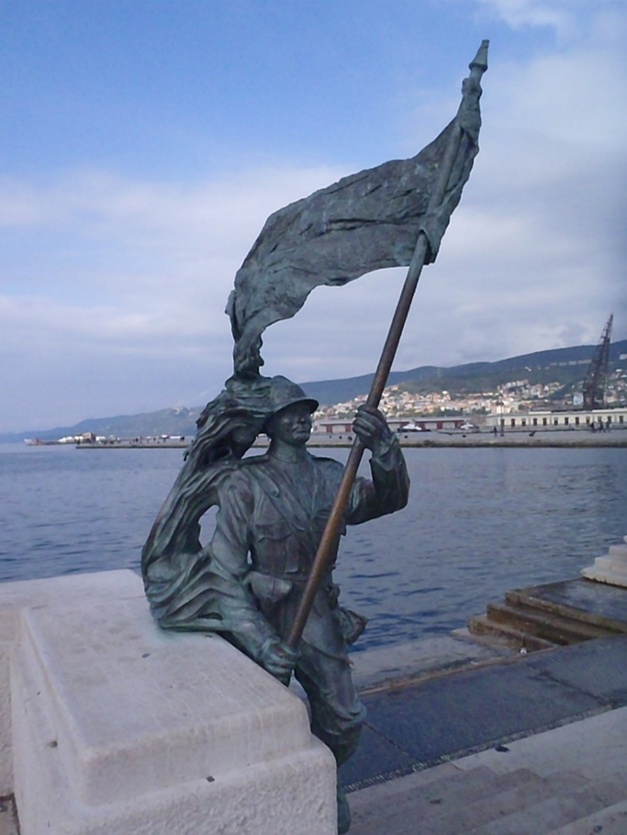

Leaving Trieste can be as discombobulating as entering it. Maybe it's the unique locale but I fared better than JJ on his first trip: When Joyce and Nora arrived in Trieste on 20 October 1904, he left Nora in the gardens outside the train station to find accommodation for the night. Once in piazza Grande he was caught up in a brawl with drunken English sailors in a bar (the Irish and English like to fight...who knew?) and was arrested by the police.

Like leaving a casual lover, you know there are more wonders to discover but there's also a time to move on. My head still spinning from the whirlwind romance of Trieste had me absent-mindedly booking the slow train to Venice. Again, the mistake led to me having the proverbial cup of coffee (or in my case, a glass of vino rosso) as I traveled through the coastal hills of Slovenia en route to the romantic waterways of Venezia.

