Peschiera (pesky-era) del Garda coulda been harder...but I found serviceable lodging at the Hotel Johnson (no relation to Howard) a short walk from the stazione. When you arrive by train the first thing you see (pic#1) begs for the Clark Griswold in you to throw a punch right on the naso. Yes, it was closed for the season but John Candy wasn't around. The mascot might as well have been holding a sign saying "Welcome to Wisconsin Dells". I mean, the expansive lake and rolling hills of pine aren't enough...welcome to Gardaland, Italy's #1 amusement park.

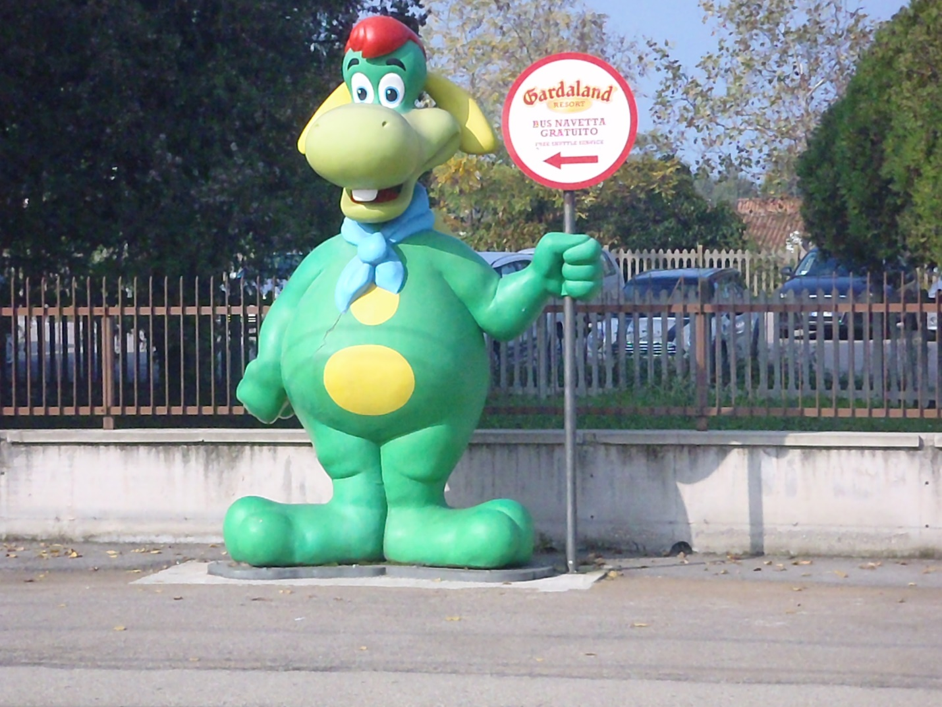

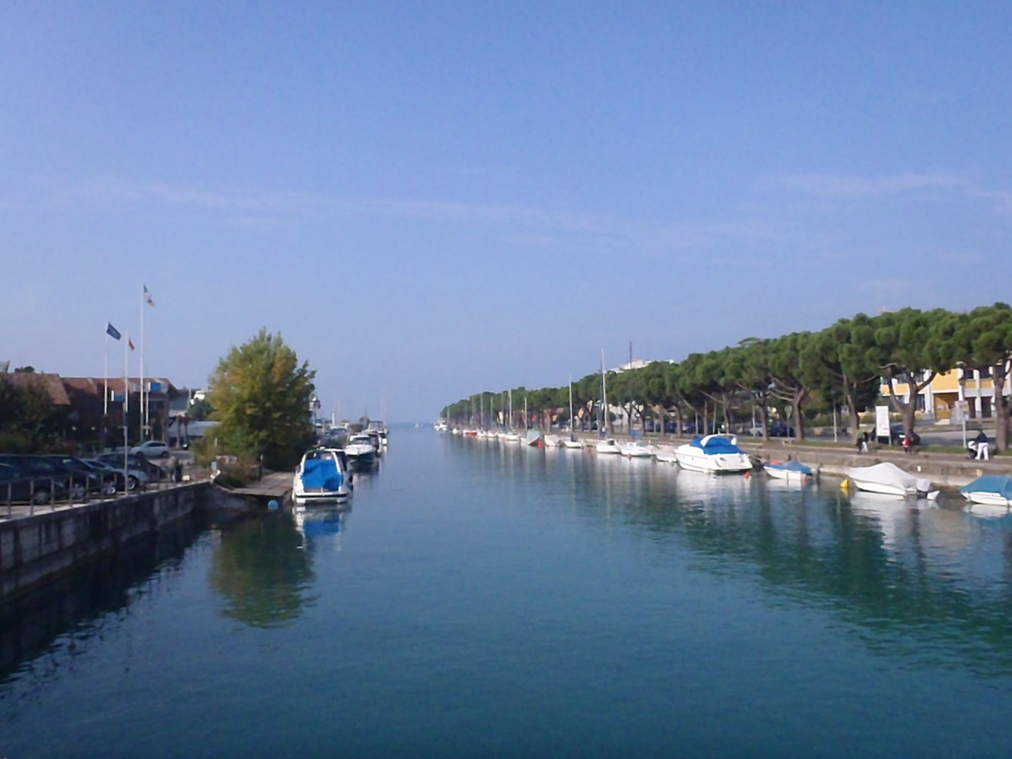

I wasn't amused. The hotel is right in the marina (pic#2) on the left-hand side and had an open restaurant serving me yet another pizza I had no hope of finishing and yet another Birra Moretti that I had no trouble finishing. I'd started eating pizza from the inside out as all they would serve is a full circle of a pizza, no slicing around, that could only be finished by a bear freshly awakened from hibernation. Fairly burnt from my gastronomical and geographic exertion, I changed into my board shorts and walked along the marina to the rocky swimming beach only to be thwarted by throngs of shirt-less Germans leaning into their suped-up VW GTIs, revving their engines and blowing gas, looking and smelling like contestants at the European plumber-butt awards.

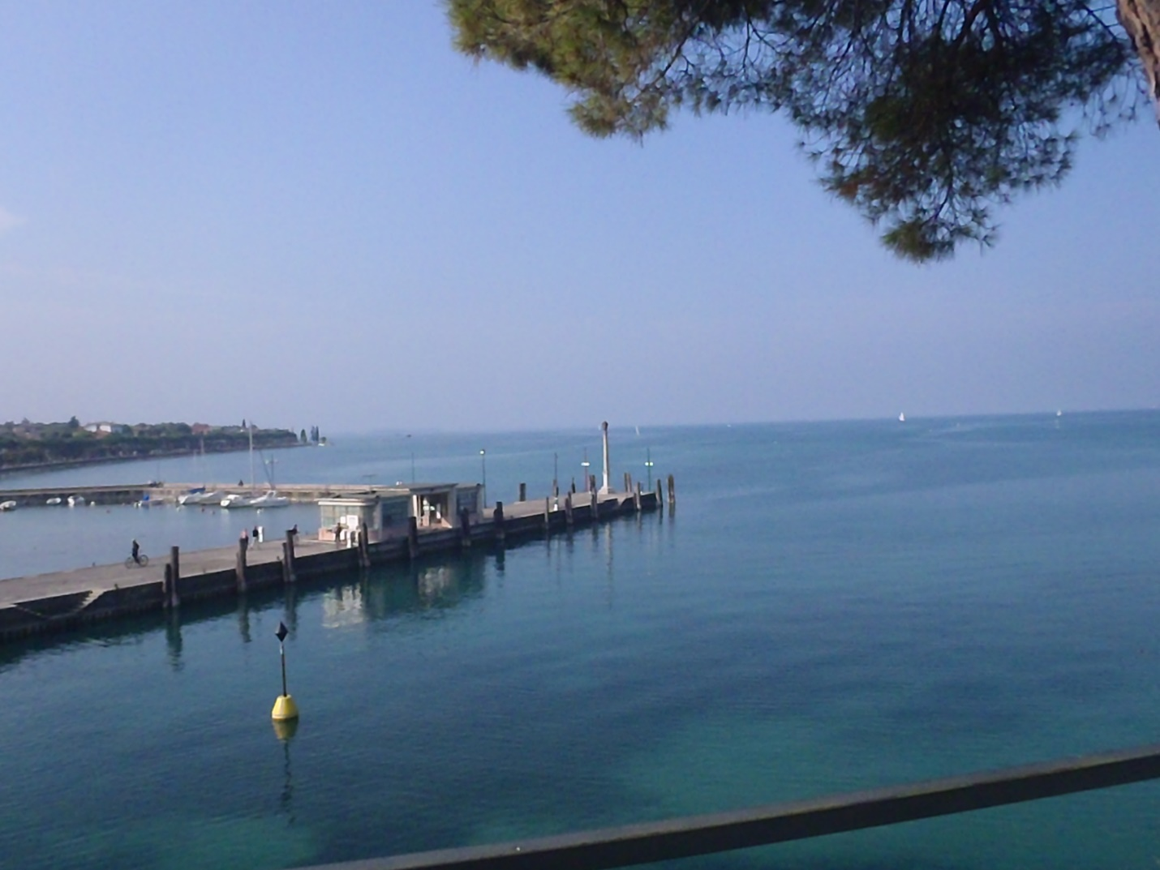

The lake itself was great (pic#3) and I vowed the next time I'd rent a boat and get to a more secluded spot away from all the cracks in culture. There were plenty of water sports outside the park. You'd see boats of all types cruising the lake and the adjacent waterways (pic#4,5) winding through town. My last Sabato in Italy and I spent it avoiding tourists and losing myself once again in the local culinary accomplishments.

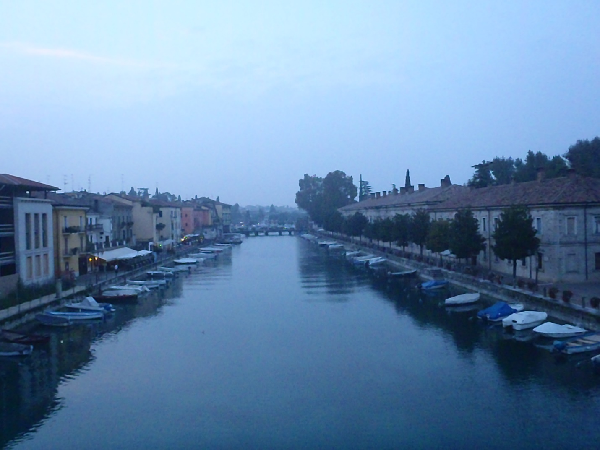

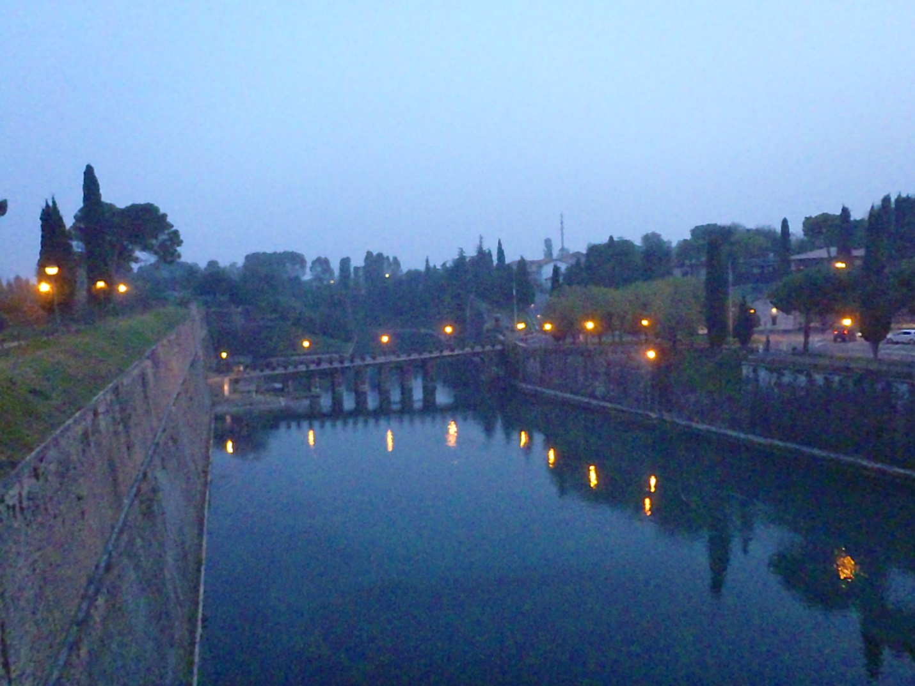

Foodie note: Dinner was at Trattoria Al Ponte Di Luca Tonoli within a short walk of the hotel. A friendly staff watched on as I progressed from the Insalata Verde to Spaghetti Con Sarde di Lago (made with sardines from the lake) and finishing with Tagliata di Manzo con Rucola e Grana...basically, beef steak tagliatelle with arugula and cheese. Tagliatelle is another of my new favorites that I can actually find around here. The waitress also gave me one of the better compliments of the trip: "You speak English like an Italian"...meaning I'd begun to speak broken English with wild gesticulations conveying my real meaning. Or, she may have said you English eat like an Italian maiale hunting for truffles...she wasn't gesticulating.

Traveler note: The "Fall back" time change happens in Europe a week before the US recognition...I guess farmers are a little slower here. Ha-ha, just kidding, no reason for leaving those John Deere tracks in my yard, whipping shitties like ten-year olds released from indenture. For me it only meant suffering through an extra hour at the bar of the stazione where they'd never heard of a screwdriver.

I looked forward to passing through Milan and on to a Como in the rain...um, I said "Como".

