II - Levanto

I had picked Levanto to visit before leaving the States. In fact, it was the only place I booked before leaving. I highly recommend B&B Vignola. Gianni, the proprietor, is a great guy.

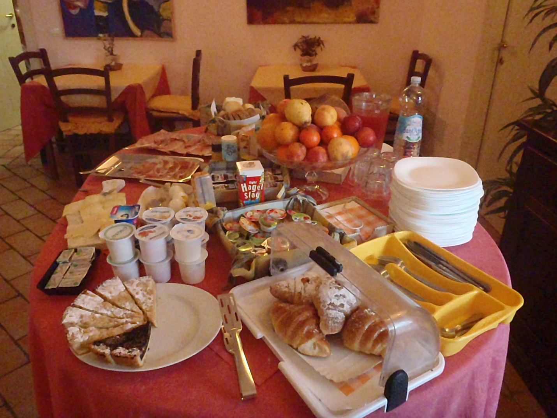

The first pic is from breakfast there every morning...with coffee of course. One of the reasons I chose this spot was for the beach with the slight possibility of surf. As you can see in the second pic, no surf but languid swimming :)

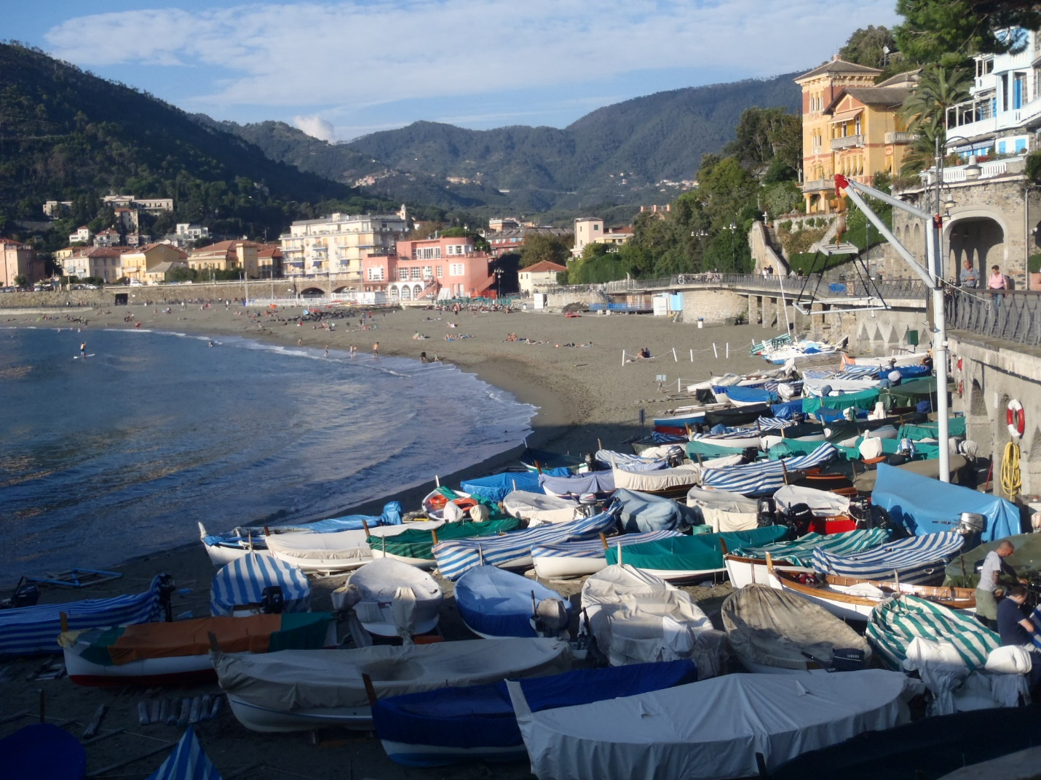

The area was also very old school. You couldn't expect englezey speakers anywhere. My B&B was up the road from the town amongst the medieval villages like the one in pic#3.

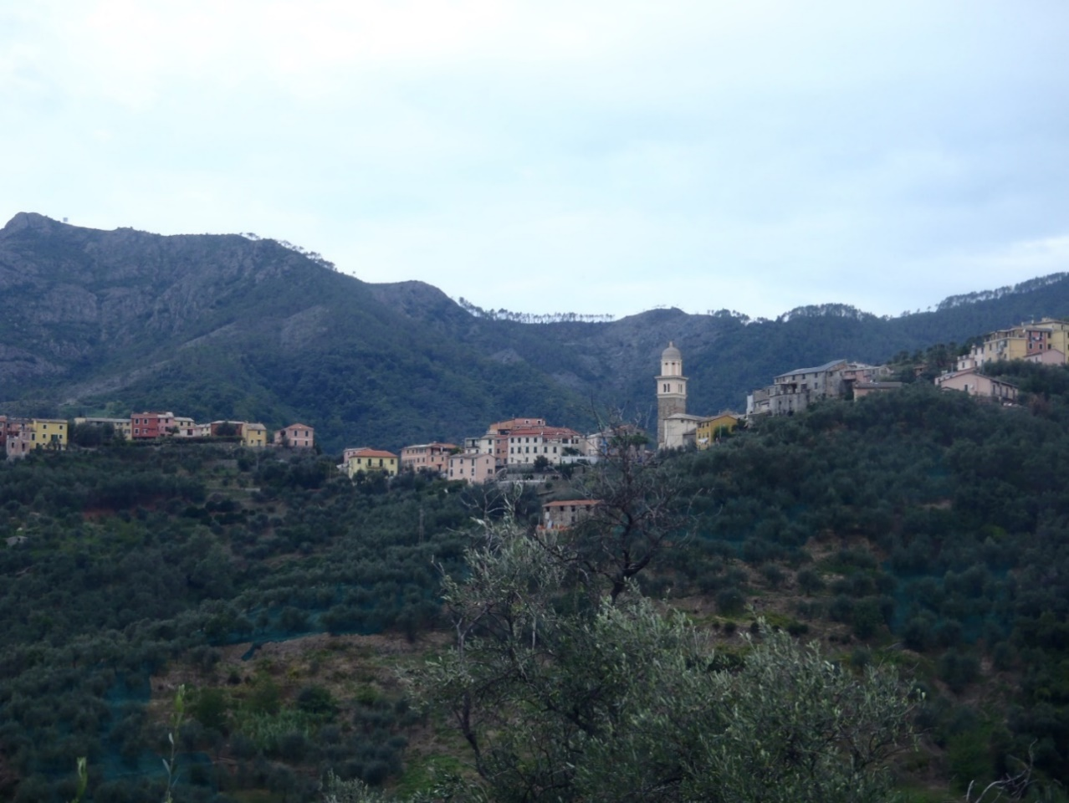

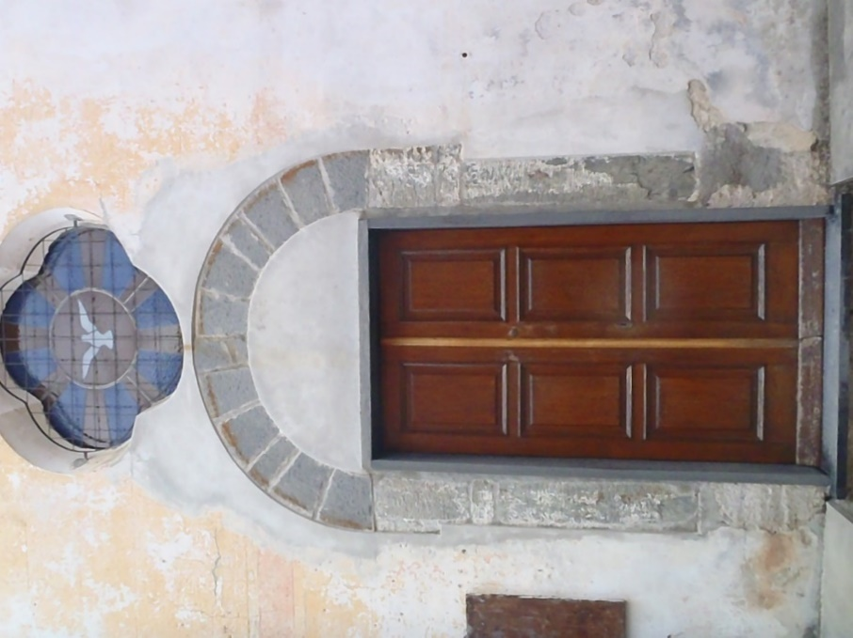

Another reason for the four night pre-planned stay here was for its proximity to Cinque Terre and great hiking. It's like the Big Sur of Italy spotted with Mediterranean villages. I hiked from Levanto to Monterosso...the most northerly town of "The Five Lands". The last pic is me checking out this cool house and the beach as I start my ascent up the trail.

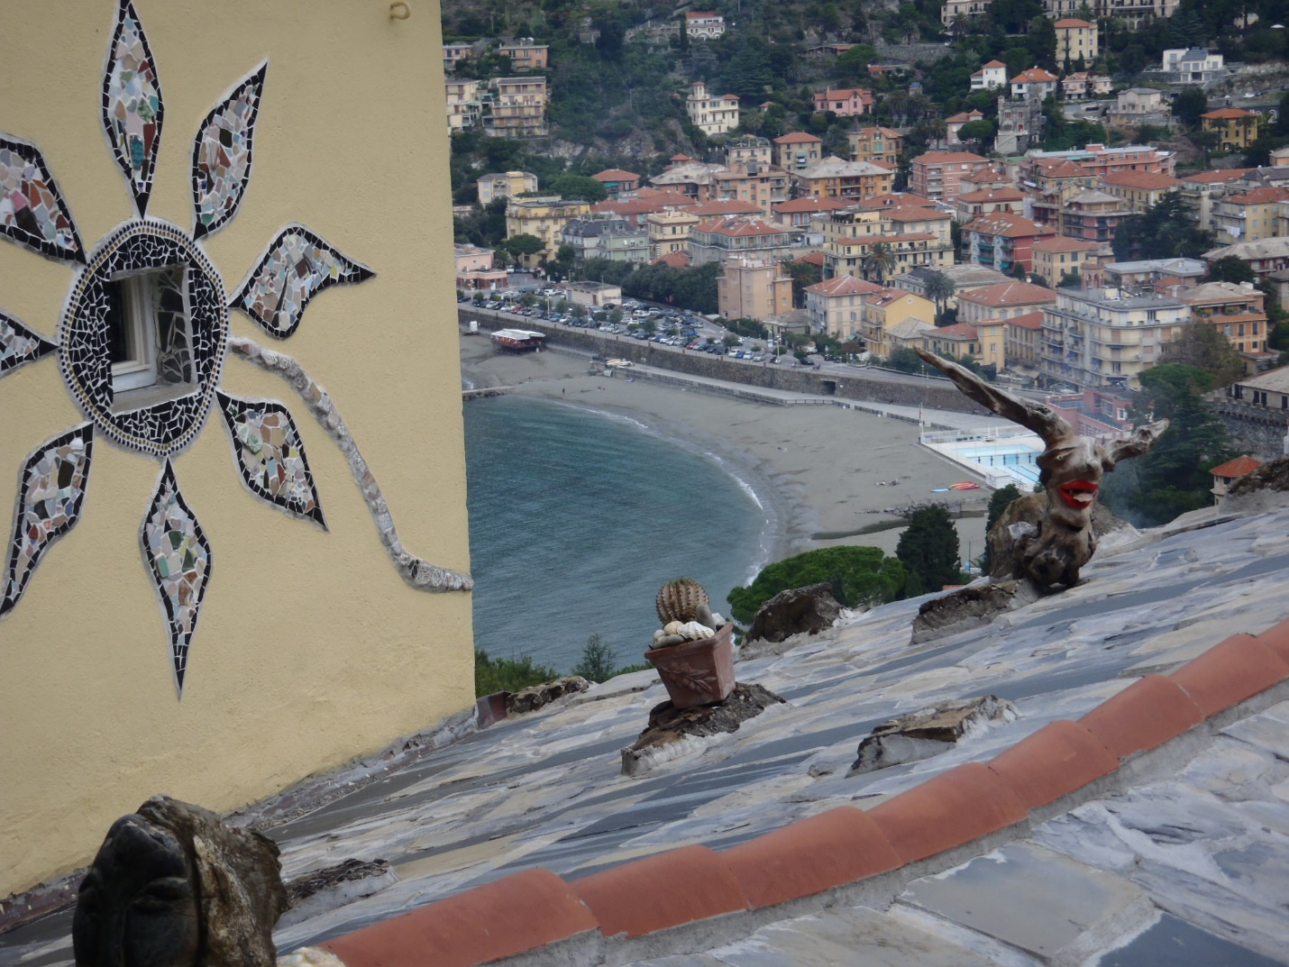

Stay tuned...next time, it's "The Path to Monterosso" (key spaghetti western music).

ciao! ciao!

