New Product Technical Brief
For Internal Reference Only

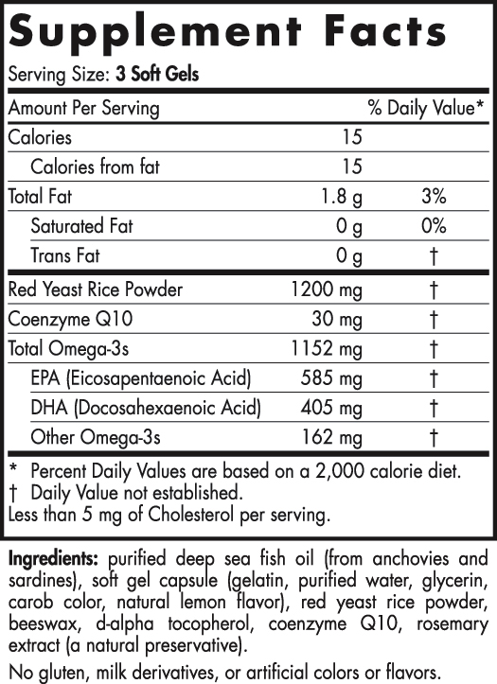
Product Name
RETAIL:
Item #
UPC Code

Professional:
Item #
UPC Code

___

Price:
60ct MSRP/Wholesale
120ct MSRP/Wholesale

Size: 60/120
Serving Size: 3
Servings per container: 20/40
___

Soft gel: 1000mg, 20 Oblong
Flavor: lemon in soft gel only
Shelf life: 36 months
Age: not indicated (adult)
Serving size provides: 585 EPA/405 DHA/1152 Total Omega, 1200mg Red Yeast Rice Powder, 30mg CoQ10

Suggested Use: Three soft gels daily, with food, or as directed by your health care professional or pharmacist.
___

Active ingredients: purified deep sea fish oil (from anchovies and sardines), red yeast rice powder, coenzyme Q10

Other ingredients: beeswax, d-alpha tocopherol, rosemary extract (a natural preservative)

Content/Packaging:
- Retail section/Classification
- Bottle size: 225cc/500cc
- Units per case

Item | Size | Weight
60ct Bottle | 225cc | 0.27 lbs
Case Pack | 10.25 x 7.75 x 5 | 3.63 lbs
120ct Bottle | 500cc | 0.69 lbs
Case Pack | 12.5 x 9.5 x 6 | 8.93 lbs

Product Rationale:

[Product Name] is a synergistic blend of fish oil, red yeast rice and CoQ10, designed to support healthy blood lipid and triglyceride levels. Targeted nutrition for cardiovascular health.

The combination is a convenient and cost-effective blend supporting healthy lipid and cholesterol levels. Fish oil has been shown in studies to raise HDL, lower TG’s and VLDL while red yeast rice has been shown in studies to consistently lower LDL levels and favorably impact lipid profiles. The combination of these two ingredients provides a brilliant, blood lipid support supplement.

Red yeast rice forms naturally occurring hydroxymethylglutaryl-CoA reductase (HMG-CoA reductase) inhibitors known as monacolins. The HMG-CoA reductase activity of red yeast rice comes from this family of naturally occurring substances. Monacolin K, also known as mevinolin or lovastatin, is the ingredient in red yeast rice that Merck & Co., pharmaceutical manufacturer of Mevacor‚ (lovastatin), asserts is a patented pharmaceutical.

However, red yeast rice contains a family of at least nine different monacolins, which work synergistically to inhibit HMG-CoA reductase. The blend is NOT considered a drug with only naturally occurring trace amounts of monaclin-K, or lovastatin. The other active ingredients in red yeast rice include sterols (betasitosterol, campesterol, stigmasterol, sapogenin), isoflavones, and monounsaturated fatty acids.

The raw material supplier also tests for citrinin in every batch of material. This is a harmful nephrotoxin that can cause damage to the kidneys and is taken very seriously. Our manufacturer actually tests down to 200ppb, which is the lowest analytical method being used. Their results show citrinin undetected at this level. We also re-test for citrinin by third party analysis and those results have always been undetected at 10ppb.

CoQ10 is added to [Product Name] LDL for additional antioxidant support and as a helpful boost to CoQ10 levels potentially reduced by the monacolin-K content of the RYR. Because HMG-CoA reductase inhibitors reduce the production of CoQ10, supplementation of CoQ10 with long-term use of red yeast rice extract is recommended.

CoQ10 provides its own benefits as a fat-soluble antioxidant and vitamin-like compound found in human cells. Inside the mitochondria of a cell, CoQ10 plays an important role in the conversion of food into energy. CoQ10 supports the cardiovascular system by helping meet the heart’s demanding energy needs and by acting as an antioxidant that protects heart tissue from the harmful effects of free radicals. Several well-designed clinical trials have found that CoQ10 supports cardiovascular health.

Key Benefits (DSHEA):

What we CAN say (examples) Use words like: supports, may improve, helps, provides, etc. Refer to a condition by its symptoms (i.e. instead of saying CoQ10 prevents poor blood lipid profiles, say taking CoQ10 with RYR supports blood lipid metabolism.)

What we CANNOT say (NOT DSHEA compliant language) Please DO NOT use the following words: reduces, prevents, relieves improves, treats, cures, etc. Also, don’t directly name a disease.

*This product is not intended to diagnose, treat, cure, or prevent any disease.

Key Selling points:
- Synergistic cardiovascular support blend
- Promotes normal cholesterol levels
- Antioxidant support
- RYR has been used in Chinese cuisine and medicinal foods for centuries to promote blood circulation
- CoQ10 from non-synthetic methods and without artificial recombinants

Key Ingredients Overview:

Purified Deep Sea Fish Oil
- Highly concentrated Omega-3 oil (EPA and DHA)
- Source: [country of origin]
- Triglyceride form

Red Yeast Rice Powder
- Organic and kosher, dark reddish powder
- Source: It is a fermented product of rice on which the fungus Monascus purpureus is grown. [country of origin]

Coenzyme Q10
- Kosher and natural, yellow to orange crystalline powder
- Source: Yeast fermentation method [country of origin]

Other Ingredient Overview:

Beeswax
Form/source: Derived from honeycomb (non-GMO)
Function: Suspension and stability

D-Alpha Tocopherol
Form/source: Sunflower Oil (non-GMO)
Function: Antioxidant for oil (preservative)

Rosemary Extract
Form/source: A miniscule amount is used, not a significant source of nutrients (leaf extract)
Function: Lipid stabilizer antioxidant for oil (preservative)

Soft Gel is made from gelatin, water, glycerin, and natural lemon flavor

Allergens: No gluten, milk derivatives, or artificial colors or flavors

[product images]

Research

Liu J, et al. Chinese Red Yeast Rice (Monascus Purpureus) for Primary hyperlipidemia: a Meta-Analysis of Randomized Controlled Trials. Chin Med 2006; 1:4–17.

Heber D, Yip I, Ashley JM, et al. Cholesterol lowering effects of a proprietary Chinese red yeast-rice dietary supplement. Am J Clin Nutr1999;69:231-236.

Wang J, Lu Z, Chi J, et al. Multicenter clinical trial of the serum lipid-lowering effects of a Monascus purpureus (red yeast) rice preparation from traditional Chinese medicine. Cur Ther Res 1997;58:964-978.

Skulas-Ray AC, et al. Omega-3 Fatty Acid Concentrates in the Treatment of Moderate Hypertriglyceridemia. Expert Opin Pharmacother 2008; 9:1237–1248.

Nestel P, et al. The n-3 Fatty Acids Eicosapentaenoic Acid and Docosahexaenoic Acid Increase Systemic Arterial Compliance in Humans. Am J Clin Nutr 2002; 76:326–330.

Biscione F, et al. Cardiovascular Effects of Omega-3 Free Fatty Acids. Curr Vasc Pharmacol 2007; 5:163–172.

Kris Etherton P, et al. for the AHA Nutrition Committee. Omega-3 Fatty Acids and Cardiovascular Disease: New Recommendations from the American Heart Association. Arterioscler Thromb Vasc Biol 2004; 23:151–152.

Ernster L, Dallner G: Biochemical, physiological and medical aspects of ubiquinone function. Biochim Biophys
Acta 1995;1271:195–204.

Ghirlanda G, et al. Evidence of plasma CoQ10-lowering effect by HMG-CoA reductase inhibitors: a double-blind, placebo-controlled study. J Clin Pharmacol 1993;33:226–229.

Marcoff L, et al. The role of coenzyme Q10 in statin associated myopathy: a systematic review. J Am Coll Cardiol
2007;49:2231–2237.

Bargossi AM, et al. Exogenous CoQ10 supplementation prevents plasma ubiquinone reduction induced by HMGCoA reductase inhibitors. Mol Aspects Med 1994:s187–193.

Tran MT, et al. Role of coenzyme Q10 in chronic heart failure, angina, and hypertension. Pharmacotherapy
2001; 21:797–806.

