As I've said before, Viareggio (rhymes with Peggy-O, more on that later) was a mistake still I verified two traveler axioms during my 22 hours in this surprise of a city.

Traveler tip #1--if you leave a place on X day, you need a place on X day
I got to Milano with nowhere booked except the 4 days in Levanto. My host in Milano, thanks Malcolm, reserved the hostel in Genoa because that was all that was available under 200 Euro (still can't figure out that key on my keyboard-it's like 5 or % or something). The same night, after warm San Miguels and penne ragu followed by a pork tenderloin the size of my head, I booked a place in Pisa. Well, I knew I had my place in Levanto until the 10th so I booked Pisa for the 11th. Later, I realized I needed to find a place between Levanto and Pisa for a night. I considered La Spezia, Livorno, et al. but instead discovered the home of the Italian Carnivale.

Mistakes can be a good thing. I realized this when I stepped off the train and walked through a seaside resort that somehow hadn't made my travel guides and reminded me of the Carolina coast. I practiced the pronunciation as I wandered to my hotel:

Will you marry me in veer-regg-io, will you marry me in veer-regg-io
If you will marry me, I’ll set your cities free
And free all the ladies in the are-o

As we rode out to fennario, as we rode out to fennario
Our captain fell in love with a lady like a dove,
And called her by a name, pretty veer-regg-io.

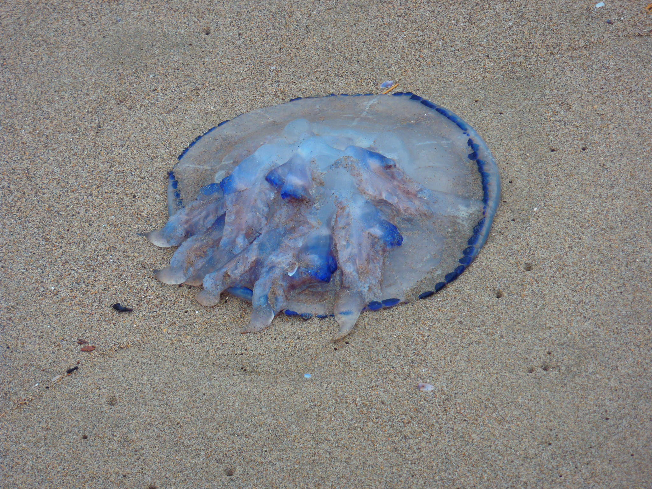

The Tyrrhenian Sea was tempting until I saw pic#1--it's a jelly!

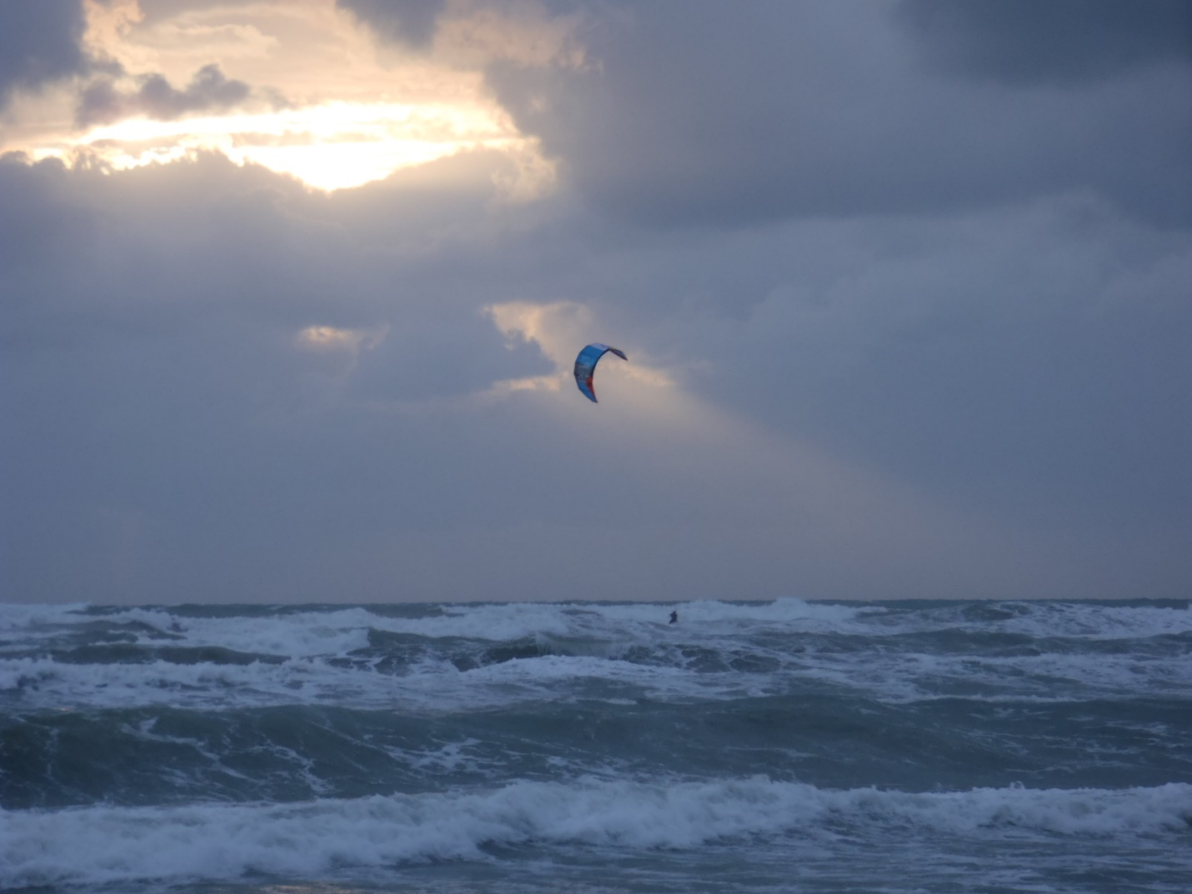

It didn't stop the kite-boarders ala Waddell Creek...and a couple of surfers came out of the water after sunset (pic#3).

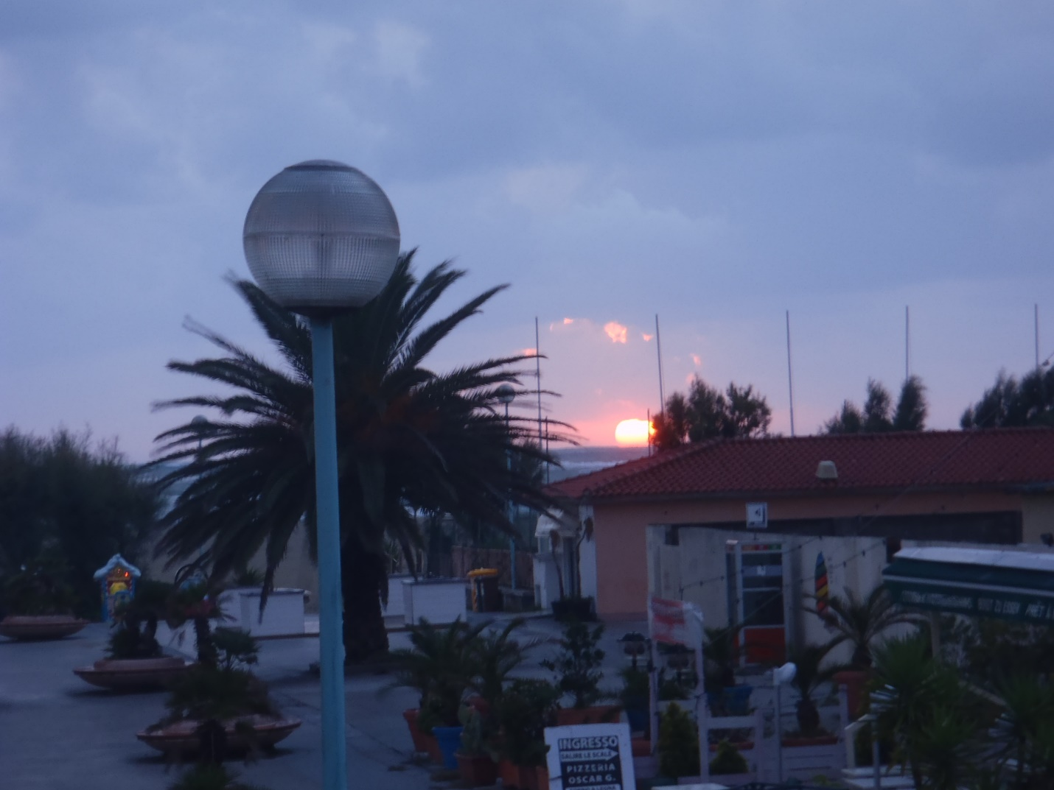

A little too burly for me though I did look for a surf rental shop. They didn't have one but I did buy my first souvenir here. I'd been resisting the urge to buy anything that I'd have to carry the rest of the trip but I ended up with a copy of I vagabondi del Dharma, the Italian version of Kerouac's Dharma Bums.

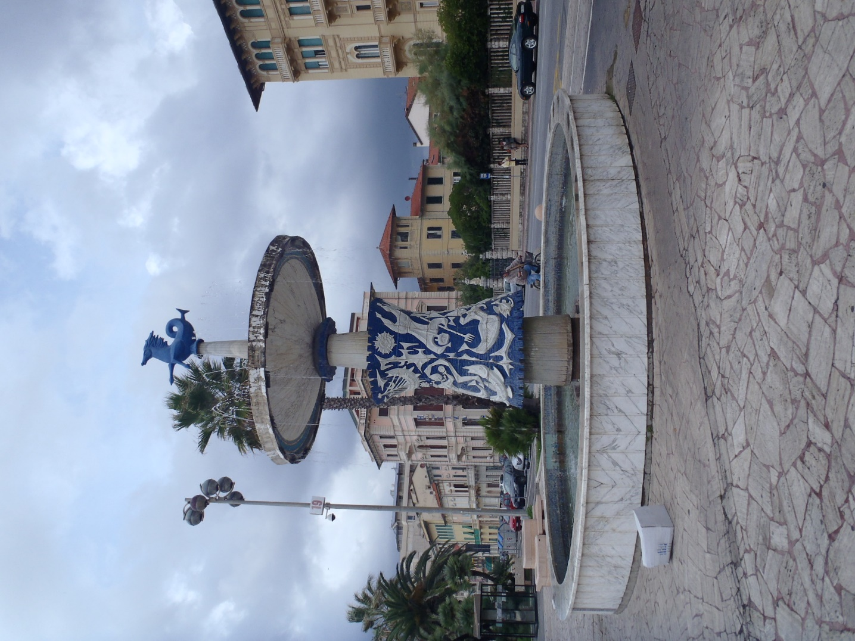

The fourth pic is the "Fountain of Four Seasons" and one reason Viareggio won the "most playful town" award of my trip. Since 1873 they've held the Carnivale parade with floats and festivities.

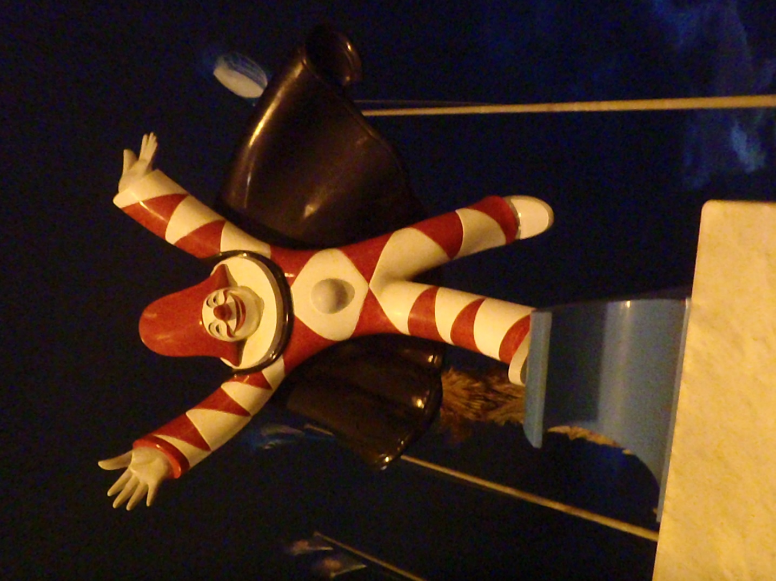

The last pic is the official mascot, Burlamacco—no song to help with that pronunciation, this statue was along the waterfront but there was also one this size in the lobby of the hotel. Mom would've of loved it though I think they are meant to encourage good times and drinking (oh no!) They have a mini-Carnivale on Halloween but, alas, I was on to Pisa.
Oh yeah, traveler tip#2: Washing your own clothes in the shower works best when you have an ocean breeze
I was ten days in and wanted fresh clothes for my journey south through Rome and Napoli. Camp Suds works great in the shower and the strong sea breeze left my clothes much fresher than the "sea breeze" scent you get in the store!

Bonus pic: the view from my room...Italia, gotta luv ya!

