Bologna, so glad to have known ya. There should have a sign when you enter the city (and maybe they do) that says “Welcome to the New World”. Talk about moving forwards. This wonder-filled city makes the Capital of The Hunger Games seem entirely plausible. There's black people with bright yellow mohawks, white people, I mean like powder white people, with cat eyes and jewels for whiskers. There are brown people with purple pompadours and yellow people with steel-gray mop tops. I'm not sure what it all means but it's fuckin' cool to check out.

My first impression was this is what I thought Milano would be. These people see a red-bearded stranger in shorts and flip-flops and they think "foreign invader." Mostly, I think they felt sorry for my lack of fashion. There was no one else who looked remotely like me and they seemed to cast a disdainful glance my way before shielding their eyes as if the sun exploded and they wanted to look at something more appealing before they died a fiery death. Or maybe I'd just taken a rare hit of Cali-kind...

It didn't help that the Polizia here look like complete badasses. No donut crumbs in the mustaches, more like, blood splatters in the beard that they'd just started that morning. When their dark, suspicious eyes took in some unkempt American gaping moronically at every passer-by, every building, every fountain (and there were a lot of them), they didn't draw their guns. They didn't have to, I was subdued. It was like they rounded up the best physical specimens of their region…like The Hunger Games. And they killed each other off until the best one won…like The Hunger Games. And they went off to live with Woody from Cheers…like The Hunger Games. And the wine must be getting to me…like a drinking game.

I promise, no more references to a certain over-popular trilogy, personally, I blame my niece. My stay was too short in this city that had so much to see. One night was certainly not enough. I mean, how could you not love a place with a Rufus Thomas Park? Actually, it's a little outside of town and is the home of the Porretta Soul Festival which heads into it's 27th year and probably a good time to go back for a visit. I settled for getting down to the "Funky Penguin" at the hostel…luckily, no roommates or any other living, breathing human being had to witness that display. It wasn't so bad…if you looked outside…the church with the entryway art in pic#1 is right across from the hostel.

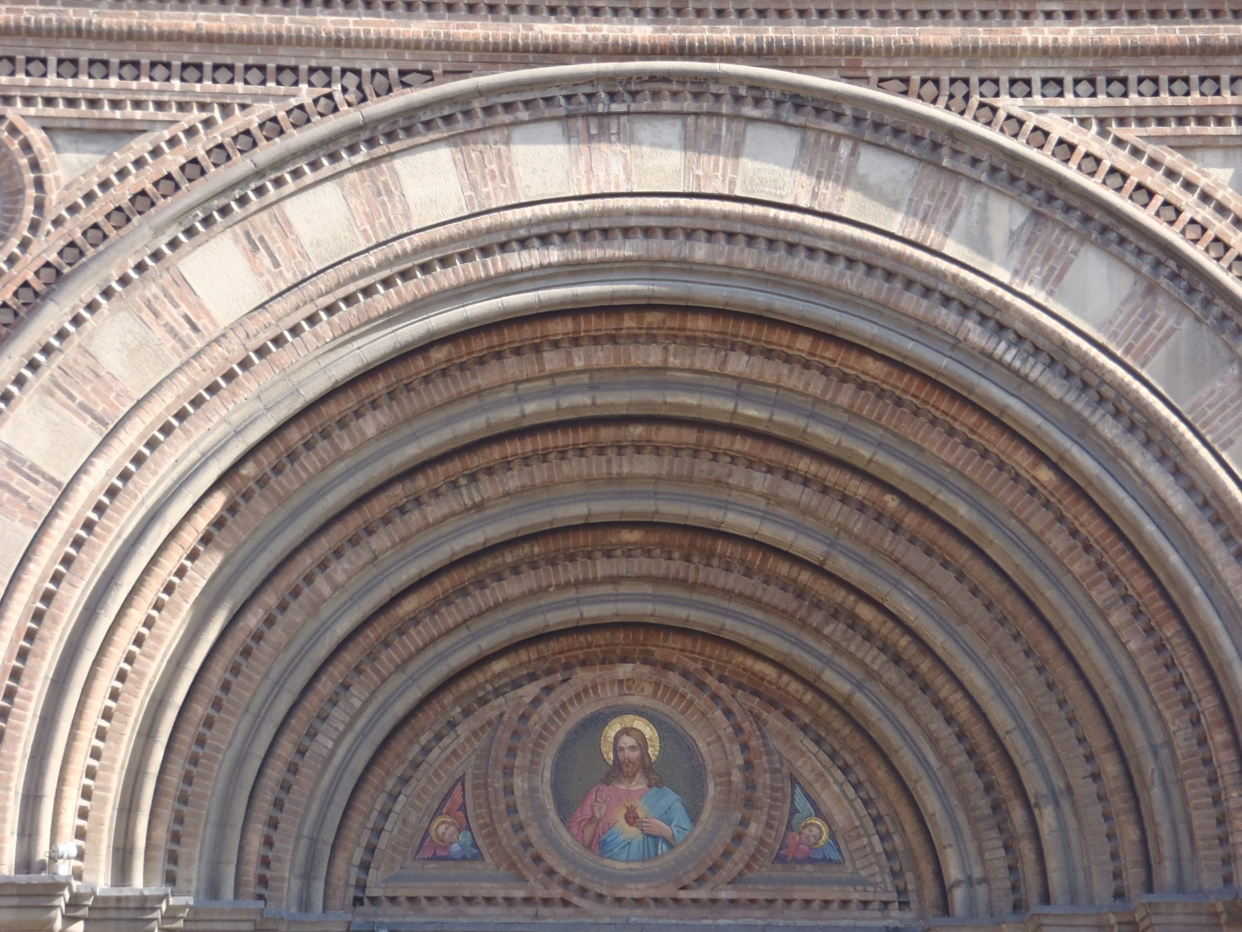

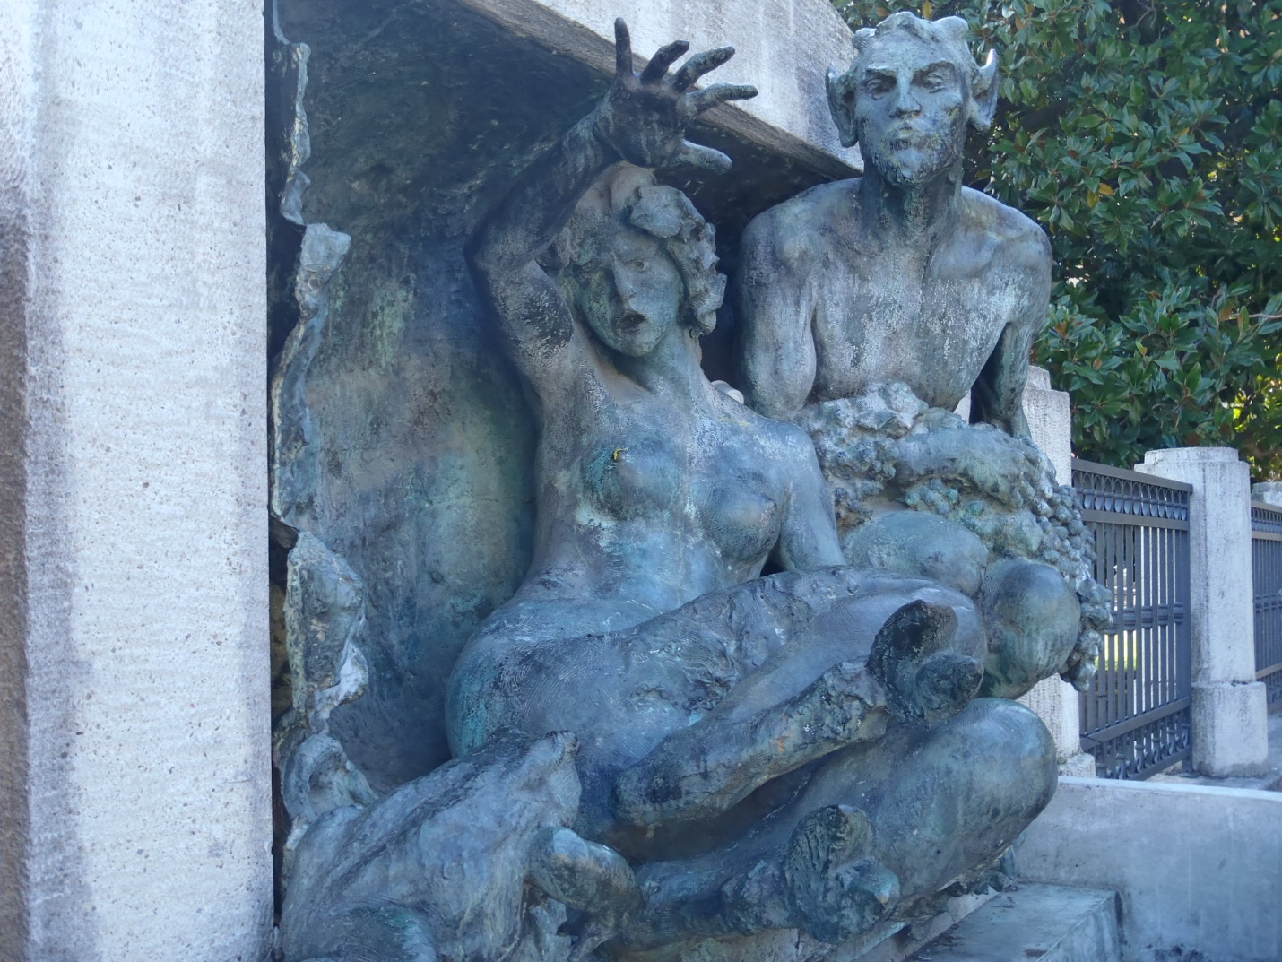

Pic#2 is one of the random statues that turned me into a slack-jawed yokel…this had happened so much that I didn't even both to take the straw from between my teeth.

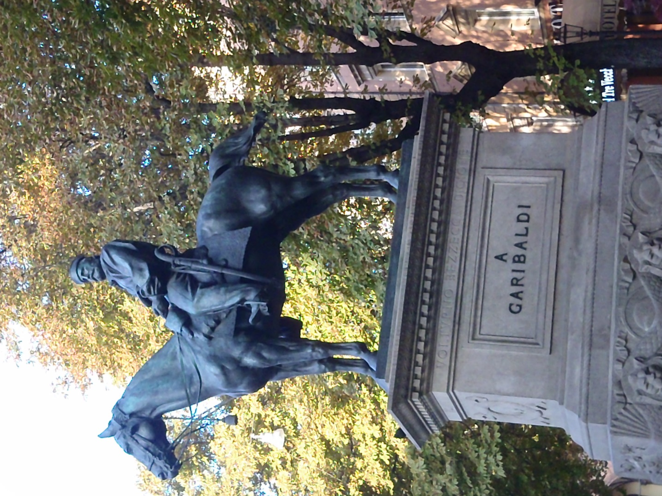

It's always nice to see a familiar face (pic#3) to make you feel a part of the "in" club. It must've been the university (the oldest in the world founded in 1088) that gave this town it's hip vibe. I didn't walk the campus as my legs were ruined (ha-ha) from Pompeii.

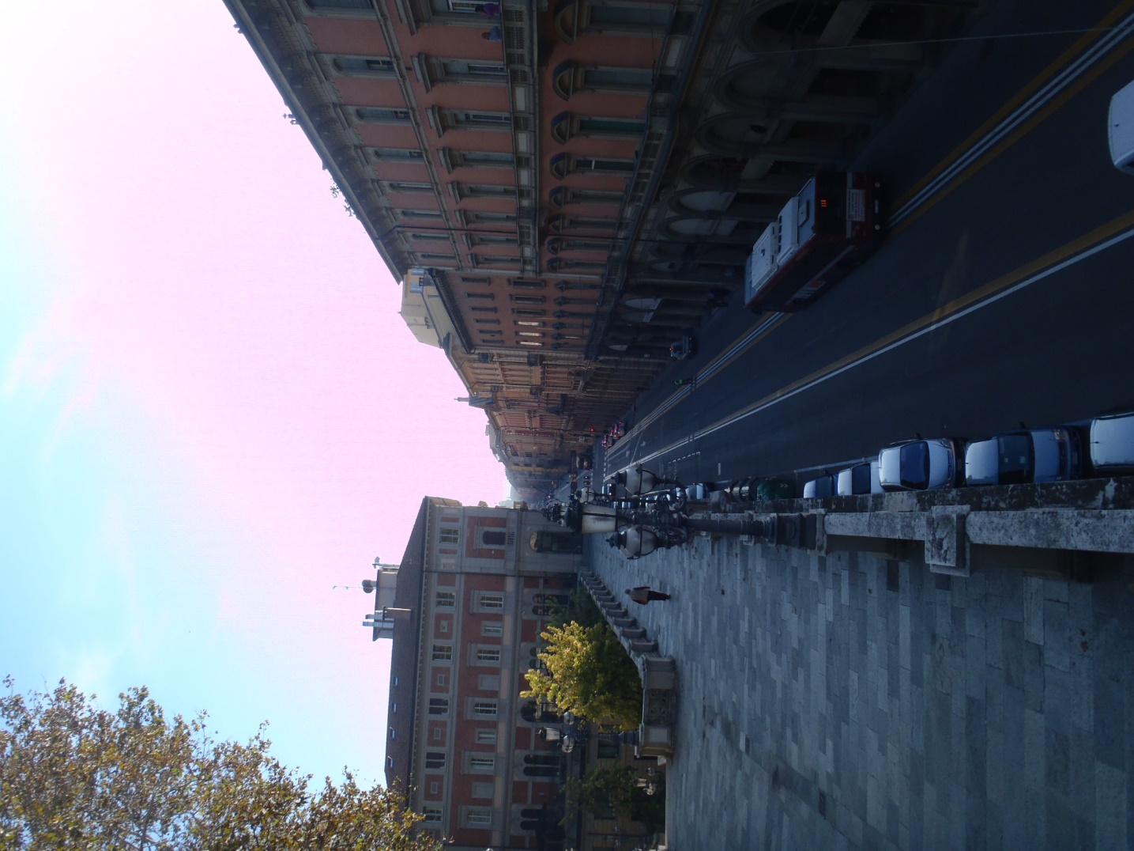

I stuck to the streets of the city (pic#4) and located a shot of Jaeger that was served in a crystal chalice and a Heineken grande. There was a leaflet advertising a violin and piano concerto but the proprietor said it would be a 20 euro cab ride so instead I discovered yet another great new dish featuring a pasta local to the Emilia-Romagna region (unbelievably I didn't have any lasagna bolognese while in Bologna): gramigna alla salsiccia…kind of a long, ribbed macaroni (get yer mind outta the gutter!) with sausage in a tomato cream sauce.

Bologna definitely won the most "progressive" city on the trip. Evidently, they also commonly win the most livable city award in Italy. If I don't come back, you know where to look for me (doh! I'm already back…at my desk, pretending to work). It may be a gross generalization from someone who squandered their educational opportunities but these students seemed to have a progressiveness of thought that reached further than fashion into all fields from government to environment, from economic to foreign policy, as if a broad education could improve the world. American students are either trying to find their place in the sty as capitalist pigs or hiding from the system altogether. Of course, their system produced the likes of Machiavelli and Mussolini while we can boast the Kennedys and the Bushs (yes, I said those names in the same breath)--I'll take the latter, except in a fist fight.
Regardless, it is great to know there's a city out there like Bologna…it gives hope to all the forward thinkers out there and, if all else fails, dye your Mohawk.

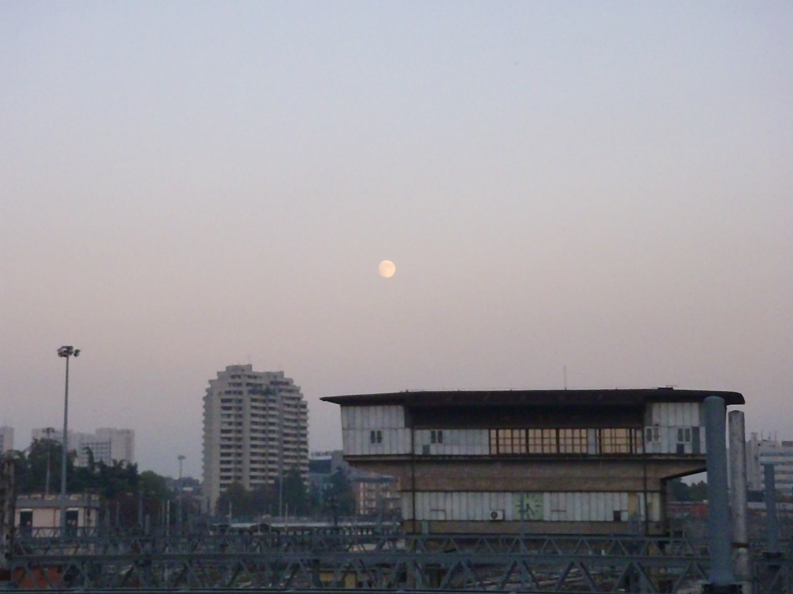

(pic#5 is a parting shot entitled "moon over centrale" definitely not the most gorgeous look but I loved every minute there with so much more minutiae to share)

